

The Holocaust
Different views, different experiences Workbook

Grade:
Name:



Date:
Name:



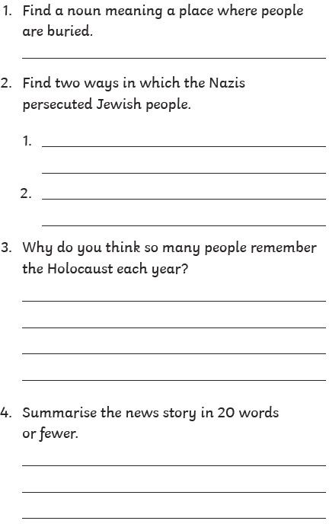
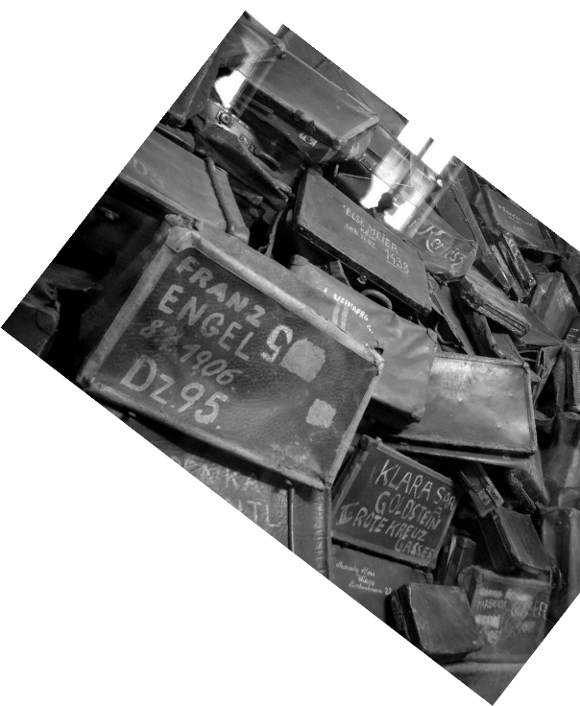
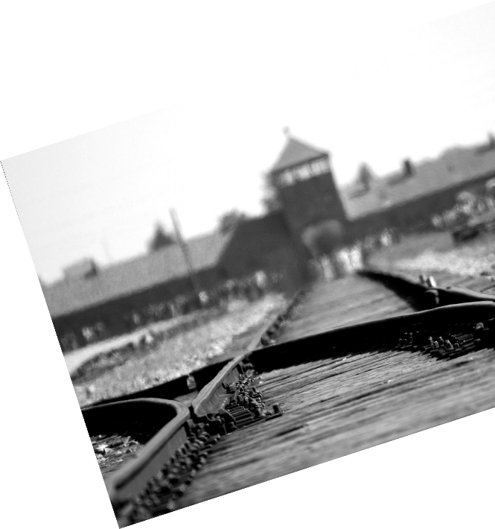
Remembering the Holocaust

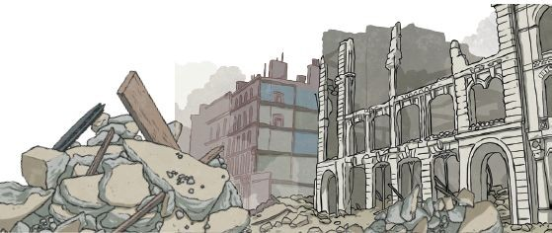
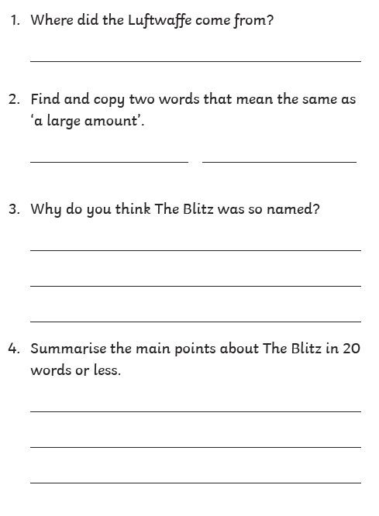

The Battle of Brittain and the Blitz

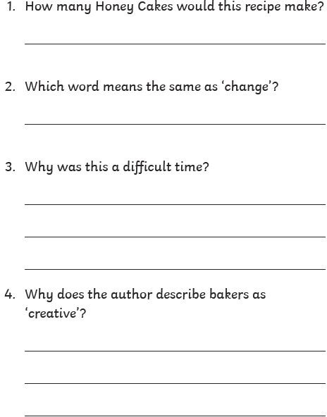
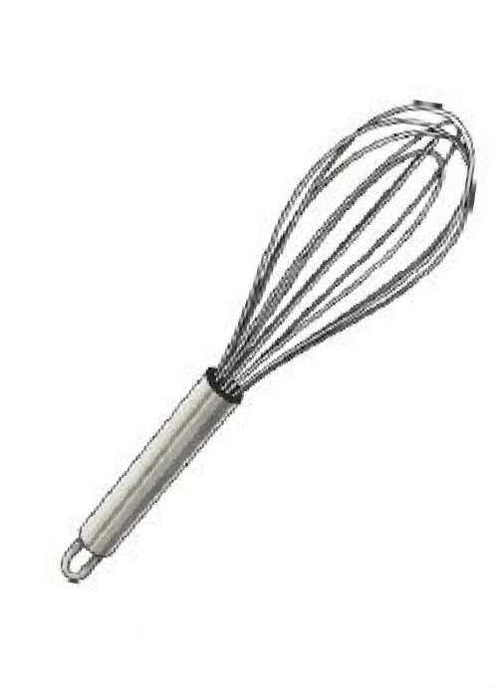
A Wartime Recipe


Rationing - A Letter Home

- Whish word means the sama as ’trode’7

- Whnt did the Grn car g ive to Ct nro7

- whish phrose telL us that CLarct was axcited about getting on orDnga7 Whg was she excitad7

h-. Whq does Clorn and hq sn qing r I
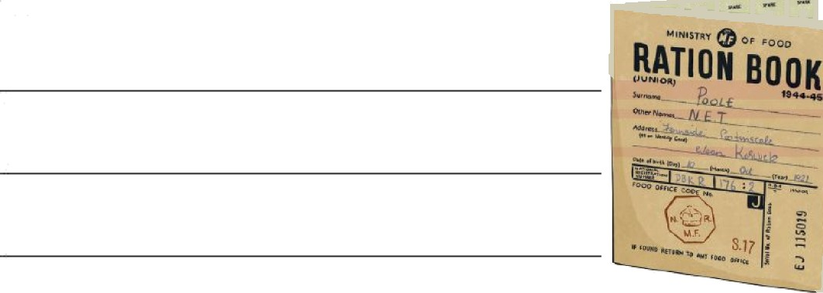
shnre with $ou’7


A Wartime Recipe
10 During the Seœnd World War, rationing (particularlg oȚ eggs and
22 sugar) meant that crœtive batters had to jînd wags tø adapt recipes
35 to ottow them to stítl enjoç ten und enhe ut this dí@icuèt time.

şjoney C«bes
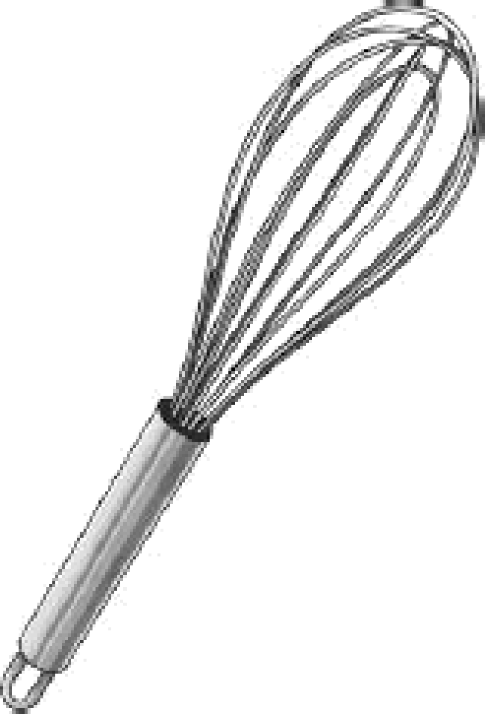
- Ingmd%nŁg:

42 • ó ounces setȚ-raising ȚlDur

45 • Z teœpooæ hone9
48 • 1 teaspoon sugar

5 ż • 2 Ț ounces margarine

55 • 1 leet toaspoon cinnamon

5ó Methoó
ó3 1. Beat sugar and margarine until it becomes ó7 a soȘ, ceamg consistency.
7ó Z. Sieve Jlour und cinnumon, add it to the mixture.
8ó 3. Nix wÎth a wooden spæn to bÎnd the mixture together,
94 bnead withȘngers untîí the dough becomes soȘ.
1O1 4. RoCt between Țloued palms into 16 balls.
109 5. PDce tbe døugh on a tigbtfg greased babing
IU tra M 7•<••ingthe rolls slÎghtlg.
123 ó. Boèe in n medïum oven @r ubout 05 mins.
1Ż8 Enjog gour delÎcious honeg cabes!


Hello Nothar,
11 Last weeb, Mm Don}ord decided that I’m sattLed enough
25 to keLp mom oround tha home so żt śs now mg job to get
35 the skopping. Atthough rationing is stitt in pfoca in the
45 countrysi&, it’s so much easżsr to g6 exŁra and borter
55 @r di@eent items. I even monagad to get an orenga -
66 con qou believe it7 The juice wos so sweet ond stickq.

75 Tha shop owrten ae much /róndLiar than in Lon&n.
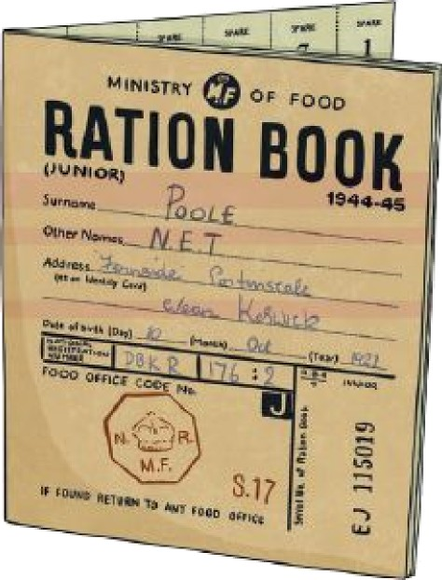
86 Thsq don't treol me ns i} I wi(1 steot /rom them;

97 | some o{ thsm even give | me | t reats | (li&s a | sweet | /mm
99 | the Grocer).
104 | O{ coume, we have ptentg
108 | o{ veg6obles: they gmw
113 | in tha huge bacb gordsn
117 | and we swap with
119 | the nsighbours.
124 | I wish I couLd zhore
126 | with yo«.
128 | Love Cl oro.


Remembering the Holocaust

7 Six unbnown Holocaust victims were buried in

1S a Jewish cemaerg on 3undag. Hundreds o/ people

23 attended the {uneraf to remember the mLtlians who
27 died during the HoLocaiJst.

36 The HoLocaust wasa time when mLtLians a{ 7ews
45 were biLted simpLg because theg were Jewish. It was SS organised bg the Nazi party, who wem in charge a/ S8 Germany /rom 1933-1945.

&4 Theg wem prejudiced against Jewish peopLe,

72 passing Laws banning them /rom geHing certoin jobs
81 and /Drcing them to move to separated living areas,
83 culled qhettos.
89 Between 1930-1945, oround six million Jewish

97 people were hitled. The Nozis nlso persecuted rind
105 hitted other qroups, such os Romo, Polish, qoq,

109 disnbted ond btoch people.

11S Everq qeor, people remember the Holocoiist

122 ond other genocides in history on Hotocoust
124 Memorinl Dog.
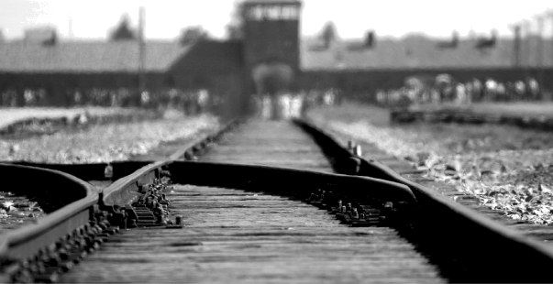
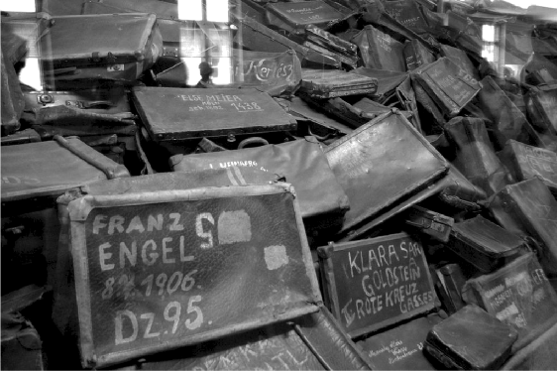



The BattÏe o/ Brítaín and The Btítz
A Tke Ba¢t& o/ Britaín
1ó This event began on the 1Oth 7ulg, 1940 when Br‹twh shaps ‹n
25 the Englwh Channet were bombed bg the Gerrnon Lu{twa@e.
33 Mass bombing oj aLr/ields, Ïzarboun, radar stat‹oru and
39 D‹rEra/t /actori«s begon ‹n August 1940.

k1 Tke BliQ

50 (The word ’8litz’ comes Jrnm the Germnn term Blctzèrèe9
£4 whzh menv ’lightnin9 wnr’.)
bti This event begun on the 7th 5eptember, 194O when the
73 Lu{two@e tu rned thei r nttention to the bombing oJ London
83 rind other citces, roth er thnn the milctor9 tn rqe ts the9 hnd
Q rRUhO LLSlfi JOKLrsed On. London wns bombed Jor JiJt9-seven
}99 consecutive nc9hts ond snor ed extermve domn9e rind the loss
105 o/tbozsonàso/mvhon!ives

