The Adventures of Henry and Lucy – The Desert Adventure (Unit 2) Activities
4th Grade

Opening: Write the day and date on the board. We suggest you start the session with a song or video (see below). Teacher and students greet each other. Engage in a conversation with the students about some of these familiar topics.

- Welcome to our lesson.
- Good afternoon, students!
Good afternoon, teacher!
- It’s nice to see you again.
I'm glad to see you too. (Explain that glad means happy.)
- How are you? What’s new?
I'm good/ I'm fine/ I'm all right
- How was your day?
It was good/ It was great/fine
- What time is it now?
- What day is today? What day was yesterday? What day will it be tomorrow? https://www.youtube.com/watch?v=h84PF1zocdQ https://www.youtube.com/watch?v=7AvNq2CQnOI
or
- What season are we in now? https://www.youtube.com/watch?v=rZ6NJWNzBqE
- What is the month? Month video: https://www.youtube.com/watch?v=rZ6NJWNzBqE
- What’s the weather like today? https://www.youtube.com/watch?v=rD6FRDd9Hew or https://www.youtube.com/watch?v=CXKj7bm4Ops
It is cloudy/ it's rainy/ it's hot/ it’s nice/ sunny/ windy
- Are you ready to start our activities today?
Yes!!

Objectives: In this unit, the students will practice:
- Varied vocabulary from Units 1 & 2
- Word sounds "-ch, -oo, -ar"
- Bingo using additional vocabulary from Unit 2

Backpacking Trip Scavenger Hunt (ציד נבלות)
This game gets students up and moving! The premise of the game is to say aloud certain items the students need for their trip – you place the printed out items in the room anywhere you wish without the students looking, then they find the printed out/tactical objects by searching around the room, kind of like a scavenger hunt. You may print the items below (keep the word and its accompanying picture attached). You also have the option to print only one copy of the items so it's more competitive, or to make it more fair you can print multiple copies according to number of students so each can find the objects at their own pace without worry of another student taking all the objects.
Steps: 1. Take a schoolbag.
2. Listen for the teacher say the object to find according to the list (below).
3. Search around the room and find the object the teacher said.
4. Place item in your bag.
5. After the game ends and all the items have been taken, each student takes out the paper/3D tactical objects in their bag and says aloud what they have.

אתם הולכים לטיול! יש חפצים בחדר וצריכים למצוא אותם כדי ללכת לטיול! כשתמצאו את החפצים, שימו אותם בתיק שלכם. הקשיבו למורה כדי לדעת איזה חפץ למצוא.
הוראות: 1. קחו את התיק גב שלכם.
2. הקשיבו למורה כשיגיד איזה חפץ למצוא.
3. חפשו בחדר ומצאו את החפץ שהמורה אמר.
4. שימו את החפץ בתיק שלכם.
5. בסיום המשחק, כל תלמיד אומר אילו חפצים הוא מצא.

  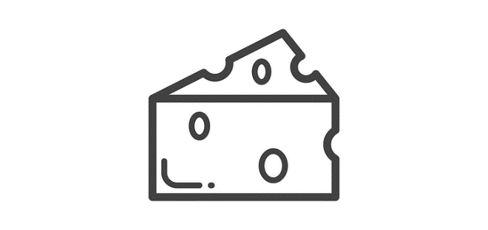 | cheese
 | chocolate
 | fig
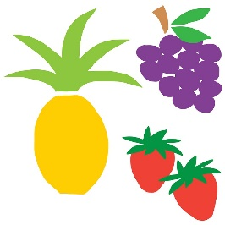 | fruits
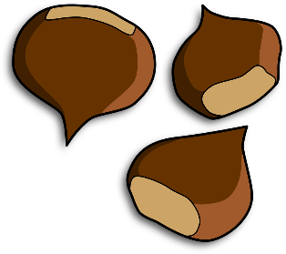 | nuts
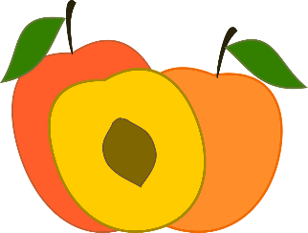 | peaches
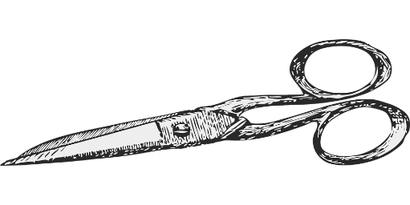 | scissors
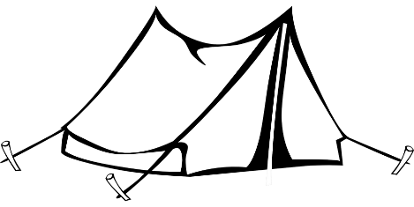 | tent
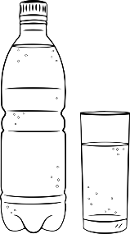 | water
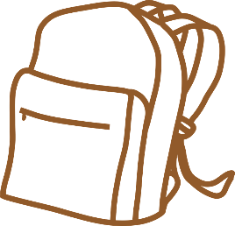 | bag
 | carpet
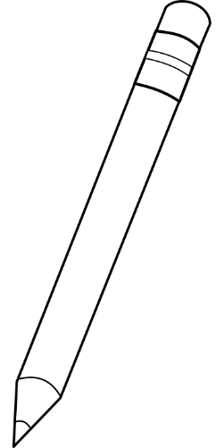 | pencil
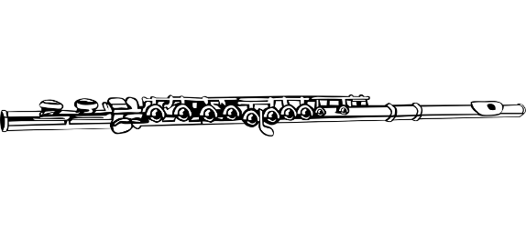 | flute
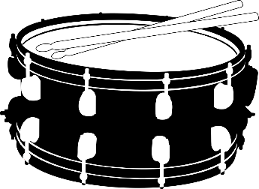 | drum
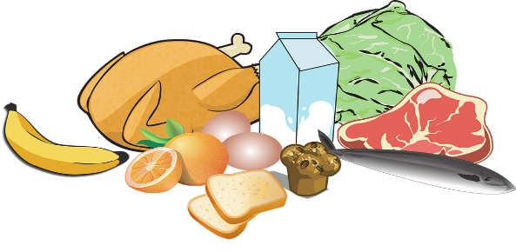 | food
 | mirror
 | shoes
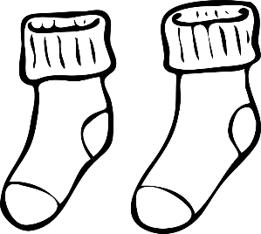 | socks
List of Items to Read Aloud:
- cheese
- chocolate
- fig
- fruits
- nuts
- peaches
- scissors
- tent
- water
- bag
- carpet
- pencil
- flute
- drum
- food
- mirror
- shoes
- socks

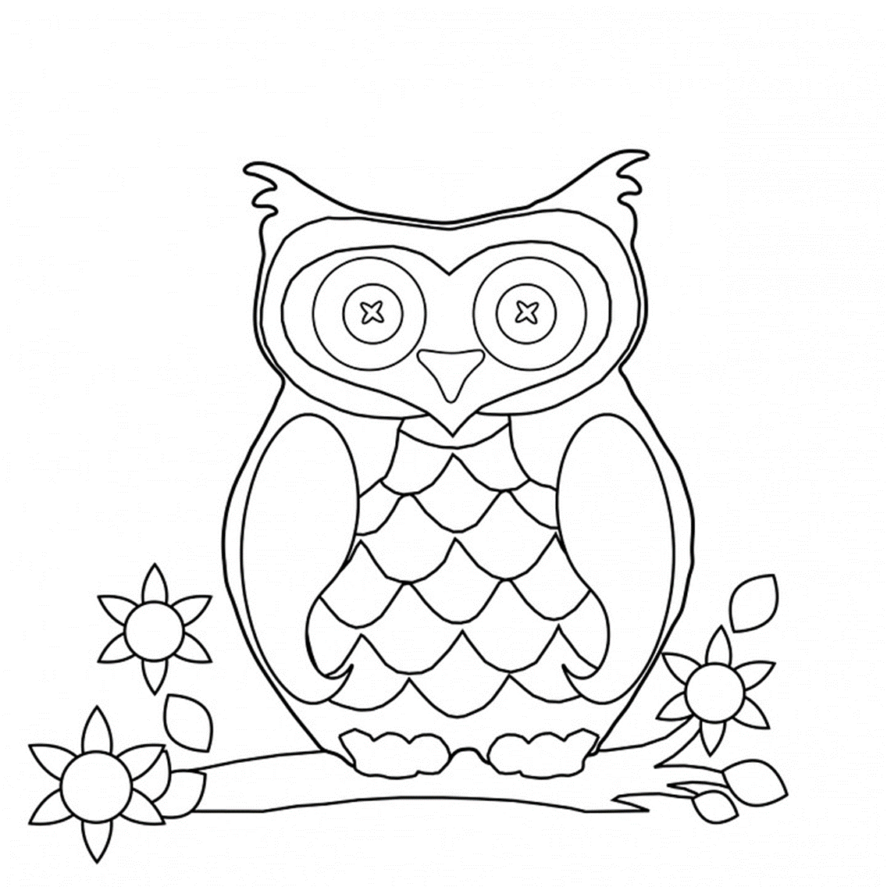
Digraph Coloring (CH, OO, AR)
Read the words written on the picture and color by code.
קראו את המילים שנכתבו על התמונה וצבעו לפי הקוד.
car

chips
child
star
peaches

far
jar
children
book
cheese
chair
moon
farm
cheese
peaches
carpet
chair

Color Code:
ar – brown
ch – yellow
oo - green

Bingo
Instructions:
Play bingo using the cards below. You will need "placeholders" for each student so they can mark which words have been called out. There are 8 different bingo boards to print out, preferably in color. Each student should receive one bingo card OR you can pair two students up and they will play as a team.
Aim of the game:
To be the first one to fill in four squares horizontally, vertically, or diagonally.
כללי המשחק:
- שחקנים מוצאים את המילה על הלוחות שלהם, לכסות אותו עם שעועית או כפתור.
- השחקן הראשון שיש "בינגו" (ארבעה ברציפות בכל כיוון - אנכי, אופקי, אלכסוני)
מנצח
- יש אפשרות לשחק בזוגות.

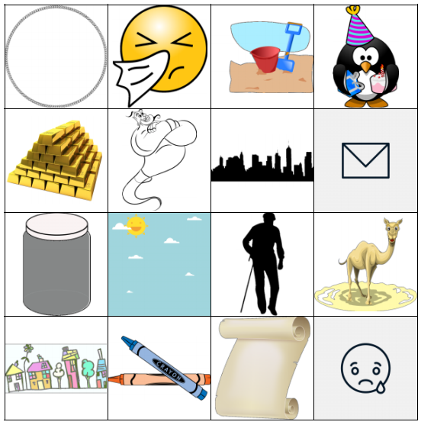

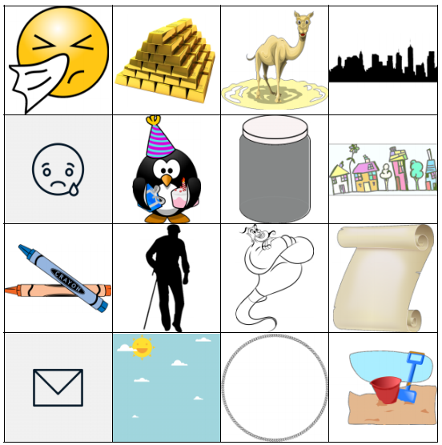
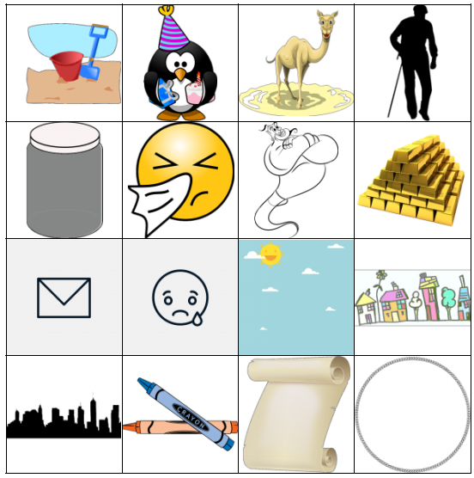

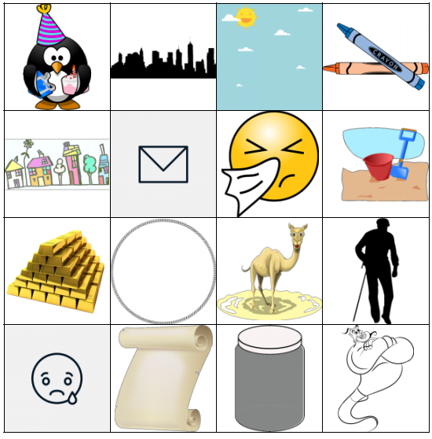
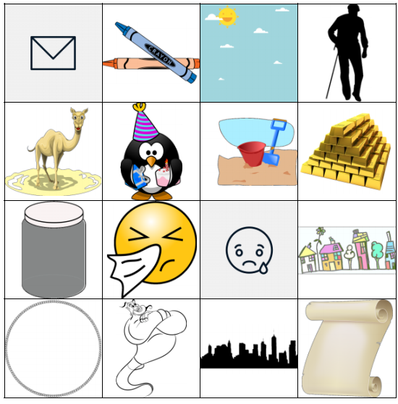

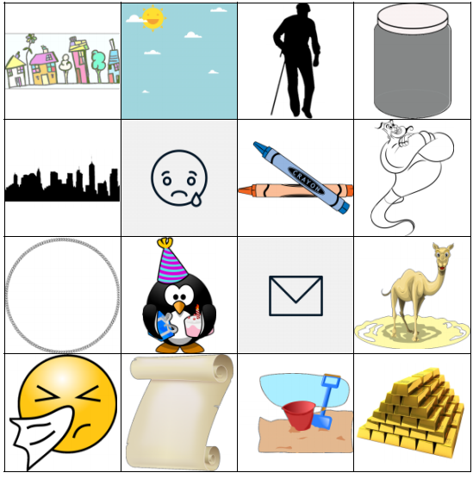
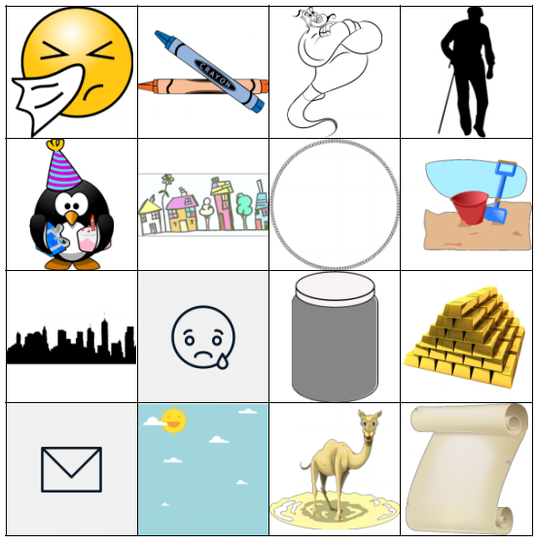
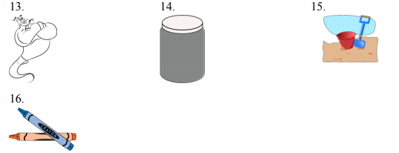
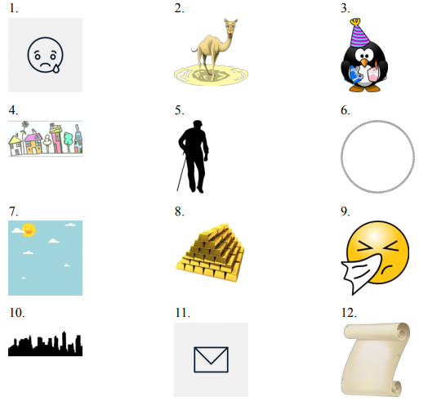
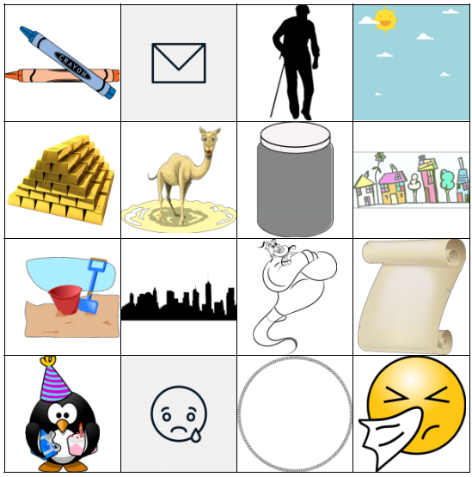
crayons
sand
jar
genie
paper
letter
city
sick
gold
sky
circle
grandfather
village
birthday
camel
sad
Use this randomly generated list as your call list when playing the game. Cross out each word as you announce it, to keep track. You can also cut out each item, place them in a bag and pull words from the bag.

Closing: Reflect on the lesson.
- For younger students, ask one thing they liked about the lesson.
- What new thing did they learn?
- For older students, ask what was special about the lesson.
- What is one question they still have?
- What would they like to learn more about?

Say goodbye to students. Tell them you are looking forward to seeing them next time… Have a good afternoon…



