Readers’ Theater
Which Shoes Do You Choose? By Aron Shepherd
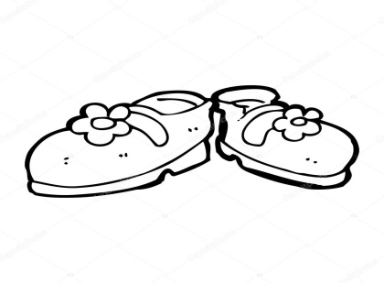
Characters:
Narrator 1
Narrator 2
Katie
Clerks 1 2 3 4 5 6 7 8 9

NARRATOR 1: Katie was tired of wearing the same old shoes.
NARRATOR 2: She went to the store to buy new ones.
NARRATOR 1: The clerks asked her,
ALL CLERKS: Which shoes do you choose?
NARRATOR 2: Katie said,
KATIE: I want shoes that are braggy, not baggy.
ALL CLERKS: (thinking about it) Hmmm. Let me see.
CLERK 1: We have small shoes,
CLERK 2: and tall shoes,
CLERK 3: and walk-on-the-wall shoes.
CLERK 4: We have red shoes,
CLERK 5: and head shoes,
CLERK 6: and down-the-hill-sled shoes.
CLERK 7: We have blue shoes,
CLERK 8: and BOO shoes,
CLERK 9: and paddle-canoe shoes.
ALL CLERKS: Which shoes do you choose?
KATIE: I want shoes that are slicky, not sticky.
ALL CLERKS: Hmmm. Let me see.
CLERK 1: We have jog shoes,
CLERK 2: and log shoes,
CLERK 3: and hop-like-a-frog shoes.
CLERK 4: We have tied shoes,
CLERK 5: and wide shoes,
CLERK 6: and carnival-ride shoes.
CLERK 7: We have trail shoes,
CLERK 8: and snail shoes,
CLERK 9: and wind-in-your-sail shoes.
ALL CLERKS: Which shoes do you choose?
KATIE: I want shoes that are spiffy, not iffy.
ALL CLERKS: Hmmm. Let me see.
CLERK 1: We have black shoes,
CLERK 2: and snack shoes,
CLERK 3: and ride-on-a-track shoes.
CLERK 4: We have wet shoes,
CLERK 5: and pet shoes,
CLERK 6: and super-speed-jet shoes.
CLERK 7: We have moon shoes,
CLERK 8: and goon shoes,
CLERK 9: and hot-air-balloon shoes.
ALL CLERKS: Which shoes do you choose?
KATIE: I choose all these shoes.
ALL CLERKS: (gasp)
NARRATOR 1: She bought the shoes and took them home.
NARRATOR 2: And now the store has
ALL CLERKS: (to audience) NO MORE SHOES TO CHOOSE!

