English Day Station Plan
Games

Name of the Game | Grape Game
# of participants:  The whole group divided into 3 or 4 smaller groups | Location of game: Classroom, in a group setting  Length of time: 15-30 min
Required materials | Cue cards with challenges according to the three different levels
Required equipment | A whiteboard and 4 whiteboard markers (the same color)
Objective of the game | Beginners - Vocabulary review  Intermediate - Sentence structure  Advanced - Answering WH questions / asking WH questions
Instructions of the game | - Draw or use the Grape Shape (see next page) on whiteboard  - Divide the class into 3 or 4 groups  - Each group has to choose a representative who will stay at the  board the whole game. His/her role is to mark the X in the  appropriate location.  - Each group member comes to the board, chooses a cue card  with the challenge and answers. If the answer is correct, the representative draws an X in one of the circles.  - The participant who draws the last X in a row gets all the points.  - When the whole board is full with X’s , we count the points.  - The winning team is the one that got the highest number  - of points.

Comments:
_________________________________________________________________________________________________________________________________________________________________________________________________________________________________________________________________________________________________________________________________________________________________________________________________________________________________________________________________________________________________________________________________________________________________________________________________________________________________

The Grape Game

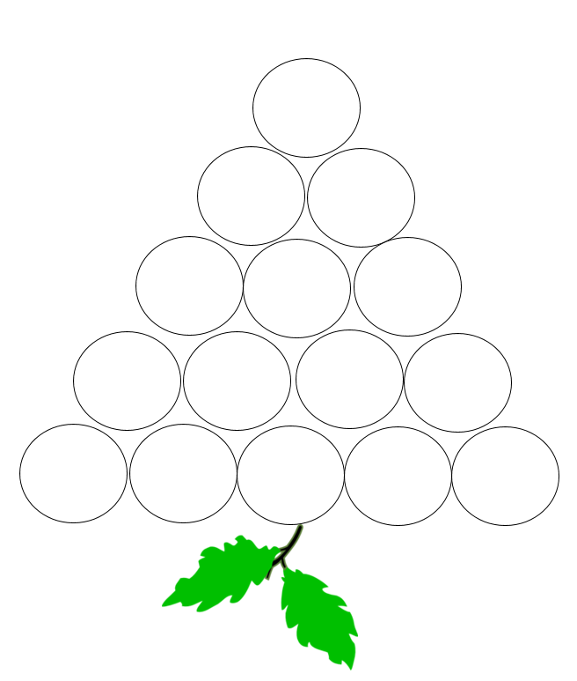
Name of the Game | Popcorn Game
# of participants:  The whole group divided into smaller groups of 4-5 participants in each | Location of game: Classroom, in a group setting  Length of time: 15-30 min
Required materials | One piece of paper per group and one pencil per group
Objective of the game | To make a list of as many words under each category as possible
Instructions of the game | - The game monitor presents one category per round (food, friendship, family, verbs…).  - The game monitor sets the timer. Each round is 3 minutes.  - Stage 1: Each group has to write as many words as possible under the given category.  - Stage 2: Each group in turn, shares one word from their list. If anyone has that word it is crossed out everywhere. If no one else has that word the group gets a point.  - The groups play until they finish crossing out or circling all their words under that category.  - At the end of each round, each group counts the number of words they circled.  - If time permits you can play 2-3 rounds (each round is a different category)
Comments:
_________________________________________________________________________________________________________________________________________________________________________________________________________________________________________________________________________________________________________________________________________________________________________________________________________________________________________________________________________________________________________________________________________________________________________________________________________________________________

Name of Game | Pocket Ball Challenge
# of participants: the whole group standing in a circle | Location of game: Classroom/outdoor/open space  Length of time: 15-30 min
Required materials | One sponge ball  At least 15 challenge cards  Music in the background
Objective of the game | To complete as many group challenges in 30 minutes as possible. The game works with cooperation between group members
Instructions of the game | - The ball contains a hole with 15 challenge cards.  - The group stands in a circle.  - When the music starts playing the pupils start passing the ball from hand to hand.  - When the music stops playing, the pupil who has the ball in his/her hands take one challenge card from the hole in the ball and reads it.  - The group has to follow the instructions and complete the challenge as fast as they can and start playing the next round.  - When the session is finished, they get one point for each completed challenge. They can compete against all the other groups that visit this station.

Comments:
_________________________________________________________________________________________________________________________________________________________________________________________________________________________________________________________________________________________________________________________________________________________________________________________________________________________________________________________________________________________________________________________________________________________________________________________________________________________________

Name of the Game | Call My Bluff
# of participants:  The whole group divided into two smaller groups | Location of game: Classroom  Length of time:15-30 min
Required materials | Cards with statements
Objective of the game | To detect the wrong statement (a wrong general fact or a grammatical mistake)  (listening comprehension)
Instructions of the game | Create sets of 3 cards.  Each card contains a fact. It can be true or false.  In each set, there is only one false card.  Divide the pupils into two or three teams.  Each group in its turn has to spot the Bluff.  The winning team is the one who was able to spot the most points.

Comments:
_________________________________________________________________________________________________________________________________________________________________________________________________________________________________________________________________________________________________________________________________________________________________________________________________________________________________________________________________________________________________________________________________________________________________________________________________________________________________

Name of Game | Word Jumble Race
# of participants: a class divided into two teams | Location of game: A big room or a yard
Required materials | Paper cups with the ABC letters on them  Cards with words
Objective of the game | To collect the correct cups with letters to spell the word that was presented to them orally or in writing.
Instructions of the game | Divide the group into two teams.  Each team in turn gets a word that they have to spell.  They have 30 seconds to run, collect the cups and put them together to spell the word.  or  You can time each group to see who is able to assemble a similar word faster.
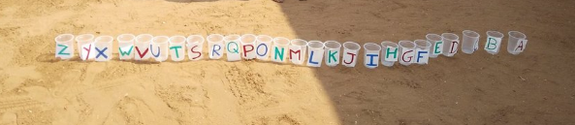
Comments:
_________________________________________________________________________________________________________________________________________________________________________________________________________________________________________________________________________________________________________________________________________________________________________________________________________________________________________________________________________________________________________________________________________________________________________________________________________________________________

Name of Game | Hot Seat Game
# of participants: Half a class | Location of game: A classroom  Length of the game: 15-30 min
Required materials | Challenge cards
Required equipment | Chairs organized in a circle
Objective of the game | To listen to the instructions and make sure they find an empty seat at the end of each round.
Instructions of the game | 1. The number of chairs in the circle should be one less than the number of pupils in each group  2. The game begins when everyone is sitting in his or her chair and one student is standing.  3. The Fellow reads the challenge card. If the fact applies to the pupils, they should stand up and find a new empty seat in the circle.  4. The students who cannot catch a chair on time and remain standing take the next challenge card and read it aloud.

Comments:
_________________________________________________________________________________________________________________________________________________________________________________________________________________________________________________________________________________________________________________________________________________________________________________________________________________________________________________________________________________________________________________________________________________________________________________________________________________________________

