If you need some new boots, you go to the…    - clothes shop  - shoe shop  - supermarket | 2  If you need money, you have to go to the…    - university  - bus stop  - bank | 3  To see different wild animals, you go to the…  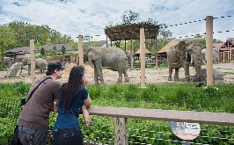  - park  - zoo  - museum
4  To buy a stamp, you need to go to the…  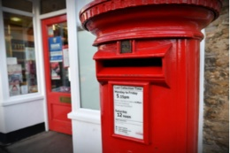  - supermarket  - butcher  - post office | 5  To eat a nice meal, you go to the…  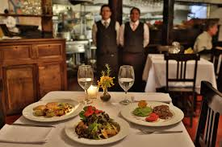  - restaurant  - supermarket  - café. | 6  To buy some milk, you have to go to the…    - baker  - post office  - supermarket
7  To buy a new sofa, you have to go to the…  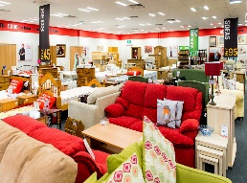  - clothes shop.  - furniture shop  - museum | 8  To learn new things, you go to…  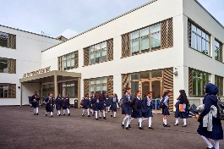  - school  - hospital  - bus station | 9  To buy a golden ring or necklace you go to the…  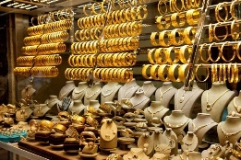  - bank  - hairdresser  - jeweler’s.
10  To buy meat & chicken you have to go to the…  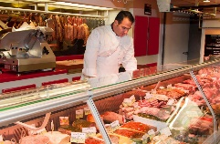  - bakery  - butcher  - cafe | 11  To have a cup of coffee, you have to go to a…  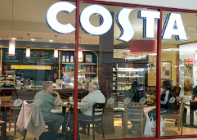  - supermarket  - cafe  - park | 12  To buy a new dress, you have to go to the…  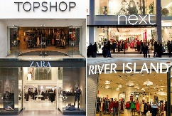  - clothes shop  - shoe shop  - supermarket
13  To catch a train you have to go to the…    - library  - bus station  - zoo | 14  If you have an accident or don’t feel well, you go to the…  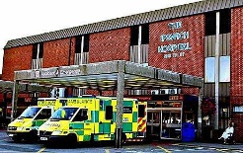  - hospital  - school  - museum | 15  Ladies, to get your hair cut, you go to the…  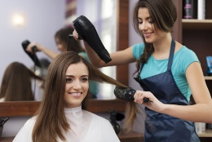  - post office  - hairdresser  - school
16  If there is a fire, you have to call…  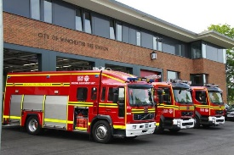  - library  - fire station  - zoo | 17  To buy a loaf of bread, you go to the…  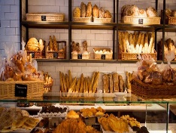  - bakery  - pharmacy  - school | 18  To get medicine, you have to go to the…    - supermarket  - museum  - pharmacy
19  To borrow out books, you have to go to the…    - fire station  - library  - restaurant | 20  To relax and have a good time, you go to a…  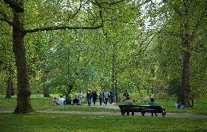  - park  - restaurant  - museum | 21  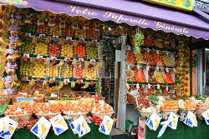  To buy fruit & vegetables, you go to a …  - supermarket  - school  - train station

Reorder the words below to make sentences or questions. Ma

Places in Town

1
Instructions:
- Have your students circle one answer for each question.
הוראות:
לענות על תשובה אחת לכל שאלה.1

