Present Simple Practice: About Me!
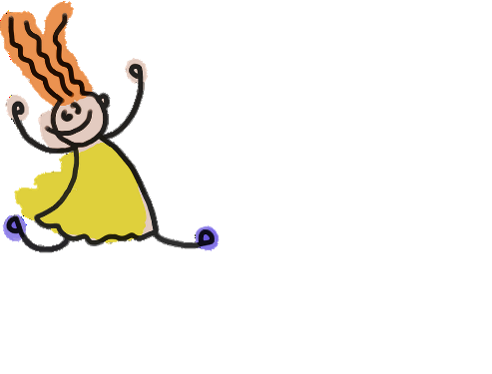
A. Write 5 facts about yourself. Use the Present Simple tense. Example: I take karate lessons every Tuesday.
1.________________________________________________________
2.________________________________________________________
3.________________________________________________________
4.________________________________________________________
5. _______________________________________________________
B. Write 5 things that you do not do. Use the negative form in Present Simple. Example: I don’t drink soda.
1.________________________________________________________
2.________________________________________________________
3.________________________________________________________
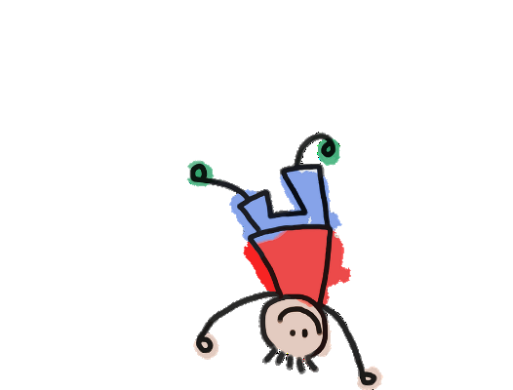
4._________________________________________________________
5. ____________________________________________________

C. Write 5 Yes/No questions based on the facts you wrote above. Use the Present Simple tense. Example: Do you take karate lessons every day?
1.________________________________________________________
2.________________________________________________________
3.________________________________________________________
4.________________________________________________________
5. _______________________________________________________

D. Write 5 WH questions that can be answered with facts from task A. Use the Present Simple tense. Example: When do I have karate lessons?
1.________________________________________________________
2.________________________________________________________
3.________________________________________________________
4.________________________________________________________
5. _______________________________________________________

