Our New Year
Write a letter to a friend who lives in another country. Tell your friend about your New Year’s celebration and ask about his/hers.

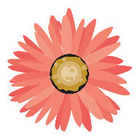

כיתבו מכתב לחבר או חברה שגרים במדינה אחרת. ספרו להם איך אתם חוגגים את בוא השנה החדשה ושאלו אותם על החגיגות שלהם.

Dear _________,

How are you? I want to tell you about my New Year’s celebration. It’s called _____________ and we celebrate it on ______________. We eat _____________________________________________. We give ______________________________________________________. We wear________________________________________. I celebrate it with _____________________________________.

Can you tell me about your New Year’s celebrations?
What is it called?
___________________________________?
___________________________________?
_________________________________?
______________________________?

Happy New Year!
______________.

