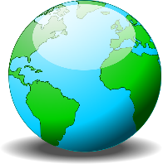
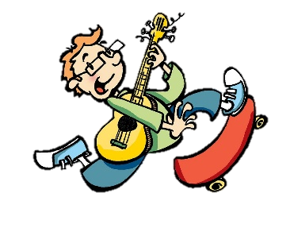

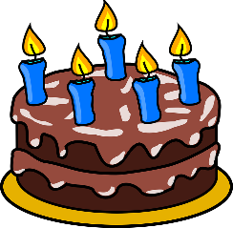

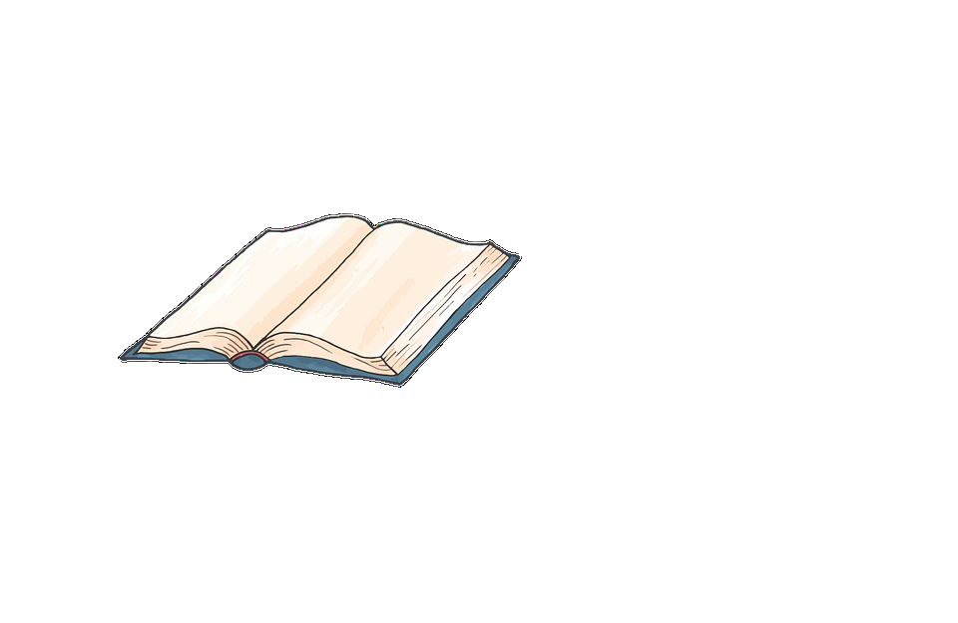
COUNTRIES
Where do you want to visit?
Why do you want to visit there?
Who do you want to go with?

HOBBIES
What are your hobbies?
Why do like them?
When did you start them?

MUSIC
What are your favorite songs?
Why do like them?
Who is your favorite singer?

BIRTHDAY
When is your birthday?
How do you celebrate it?
What presents do you like?

MOVIES
What is your favorite movie?
Why do like it?
When did you see it?

SCHOOL
What is your favorite topic in school?
Why do like it?
How often do you study it?

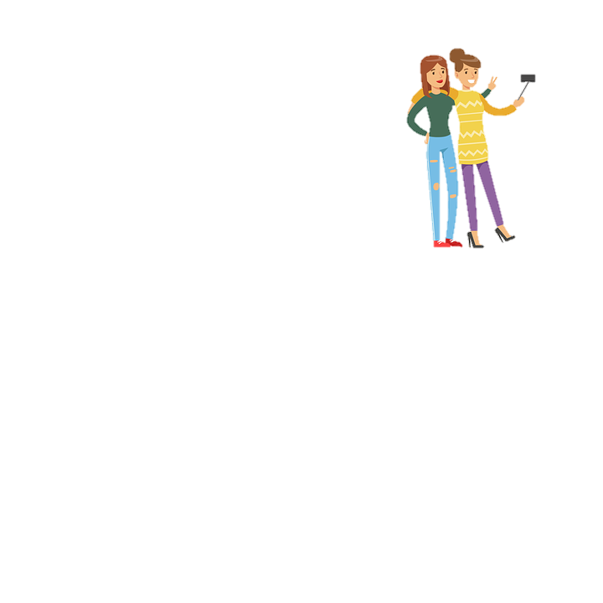
FRIENDS
Who is your best friend?
How often do you see each other?
Where does he/she live?

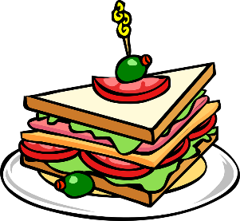
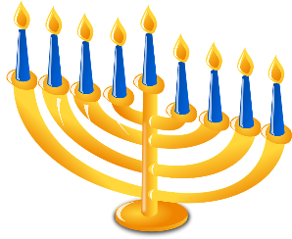
FOOD
What is your favorite dish?
Who makes it?
When do you eat it?
HOLIDAYS
What is your favorite holiday?
Why do you like it?
What do you eat or drink on it?

