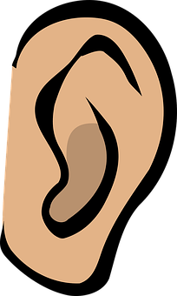
Listening Exercises
Level: Native
Grade: Junior High School/ High School

Listen to and watch some interesting Ted Talks with the students
Have a discussion about the talk afterwards.

Some interesting talks: (Watch these before you show them to the class!)
https://www.ted.com/talks/amy_cuddy_your_body_language_shapes_who_you_are?language=en#t-296847
Follow up questions: Does anyone have an experience of when they felt very confident, and what their body language was like at that time?
Have you seen examples around you of the way people move and the relationship that has with the confidence they exude?
What are some things you have taken away from this talk?
https://www.ted.com/talks/celeste_headlee_10_ways_to_have_a_better_conversation?language=en#t-29088
What were some of the 10 ways to have a better conversation?
Anyone have any examples of great conversations they have had using these techniques?
Anyone have any examples of bad conversations in which they didn't use these techniques?

For other Ted talks:
https://www.ted.com/talks?sort=popular&language=en

