Creative Writing Ideas
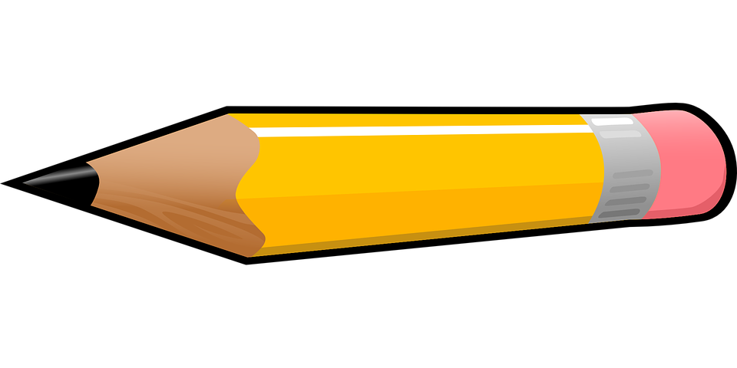
Level: Native
Grade: Junior High School/ High School (Or any students who can write confidently)

Time: 10-15 minutes

Have each student look at the 14th photo from their phone. Then have them free-write about that photo for 10 minutes.
Electricity is a recent discovery. Think of 12 things to do when there is no power.
Make a list of 10 things that happened to you this month. They can be funny, embarrassing, happy, or infuriating. Then pick one from your list and write about it.
Write about a brief but scary encounter with one of your old teachers.
Write about one of your most memorable house moves.
Where do you go when you want to get away from the pressures of life, family, school, etc? Write about that place.
In 400 words, create your ideal place.
Write about what you would say to an uninvited guest.
Write about a joyous moment.
Write about the biggest lie you've ever told.
List the names of 5-8 of your relatives and write a profile (in 50 words or less) of each.
More examples:
http://creativewritingprompts.com/#

Time: 15+ minutes (maybe if they are writing an entire story over several days)
Have the students choose a genre (fantasy, sci-fi, dystopia, thriller, mystery, non-fiction)
Have each student brainstorm ideas about characters, setting, plot, etc.
Give the students examples of these things.
Give the students helpful tips for writing if they get stuck.
Helpful tips:
https://self-publishingschool.com/fiction-creative-writing-prompts/

