Missing a Day in School

Your friend was sick with flu and missed a day in school. Write him/her an email message and tell her what happened today in school. Your message should include greetings, details of the work she/he missed in the different subjects in class, and the homework.

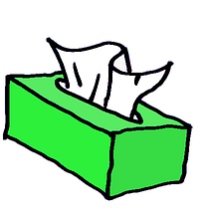


Dear __________,
__________________________________________________________________________________________________________________________________________________________________________________________________________________________________________________________________________________________________________________________________________________________________________________________________________________________________________________________________________________________________________________________________________________________________________________________________________________________________________________________________________________________________________________________________________________________________________________________________________________________________________________________________
Get Well Soon!
________________

