
would

vs.

used to

When we talk about events, states, or habits that took place in the past and are not happening now, we use used to and would.

Used to: My father used to live in Paris.
- For actions and states
- Negative: didn’t use to
- Questions: Did (he) use to…
- Used more often
Would: We would visit my grandmother every summer when I was little.
- For an event that happened many times
- More formal
- No negative or question

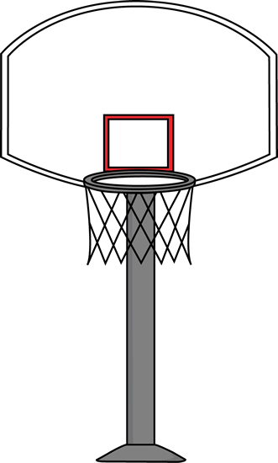
Fill in the correct form of used to or would
If both answers are possible- use would

1. Michael Jordan ____________ live in Brooklyn, N.Y.
2. When he was young, he _________ often play basketball with his older brother.
3. He ____________ (not) play only basketball- he played football and baseball too.
4. He really wanted to grow tall- so he _________ put salt in his shoes and pray. And it worked- he did grow tall!
5. When he was a child, he ________ often dream about winning an Olympic gold medal.
6. When Michael Jordan played in the NBA, there _______ (not) be 30 teams as there are today.
7. _______ you _________ cheer for Michael Jordan when he was a Chicago Bulls player?
8. Scottie Pippen is the youngest of 12 children and he _________ live in a small town in Arkansas.
9. When he was young, he _______ dream about making the winning shot in the 7th game of the NBA championship.-
10. ______Scottie ________ play basketball very well?
11. He was on his high school basketball team, but he __________ (not) play very much.
12. Pippen ________ be so skinny- he weighed 68 kilos- no college offered him a scholarship..
13. So his coach found him as job as basketball team manager at the University of Central Arkansas where he ________ be in charge of equipment and laundry for the team.
14. He ___________ (not/play) basketball very well- he _______ be on the reserve team.
15. Because many players quit the team, Pippen got a chance to play. He _________ score 4.3 points per game.
16. Not many people _________ watch his games. He was almost unknown.
17. Michael Jordan ________ always stick his tongue out when he was making a shot.

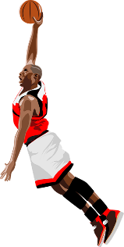



Fill in the correct form of used to or would (FOR TEACHER)
If both answers are possible- use would

1. Michael Jordan used to live in Brooklyn, N.Y.
2. When he was young, he would often play basketball with his older brother.
3. He didn’t use to (not) play only basketball- he played football and baseball too.
4. He really wanted to grow tall- so he would put salt in his shoes and pray. And it worked- he did grow tall!
5. When he was a child, he would often dream about winning an Olympic gold medal.
6. When Michael Jordan played in the NBA, there didn’t use to (not) be 30 teams as there are today.
7. Did you use to cheer for Michael Jordan when he was a Chicago Bulls player?
8. Scottie Pippen is the youngest of 12 children and he used to live in a small town in Arkansas.
9. When he was young, he would often dream about making the winning shot in the 7th game of the NBA championship.-
10. Did Scottie use to play basketball very well? No, he didn’t.
11. He was on his high school basketball team, but he didn’t use to (not) play very much.
12. Pippen used to be so skinny- he weigh 150 pounds or 68 kilos that no college offered him a scholarship.
13. So his coach found him as job as basketball team manager at the University of Central Arkansas where he used to be in charge of equipment and laundry for the team.
14. He didn’t use to (not/play) basketball very well- he used to be on the reserve team.
15. Because many players quit the team, Pippen got a chance to play. He used to score 4.3 points per game.
16. Not many people used to watch his games. He was almost unknown.
17. Michael Jordan would always stick his tongue out when he was making a shot.
18. Jordan and Pippen used to be called the greatest duo in basketball. Has any other duo taken their place yet?

