השלימו את המשפטים וכיתבו משפטים חדשים במשבצות הריקותComplete the sentences and write new sentences in the blanks -


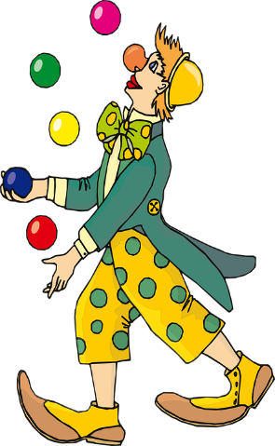
1. Who is he?
He is a doctor.
He is nice.

5.___________________?
________________.
__________________.


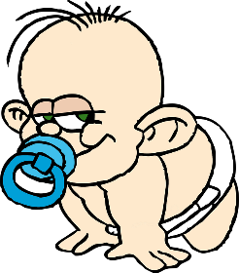
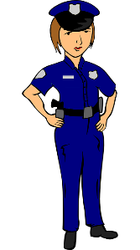

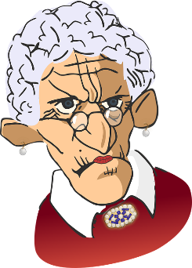
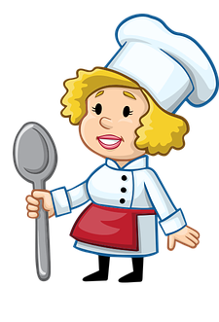
2.Who is she?
She is a _________.
She is ___________.

4.___________________?
________________.
__________________.

3.Who are__________?
_____are __________.
________ are_______.

Who is he?
Who is she?
Who are they?

6.___________________?
________________.
__________________.

7.___________________?
________________.
__________________.

