The Food Song
https://www.youtube.com/watch?v=frN3nvhIHUk

Do you like apples?
Yes, I like apples.

Do you like oranges?
Yes, I like oranges.

Do you like candy?
No, I don't like candy.

Do you like chips?
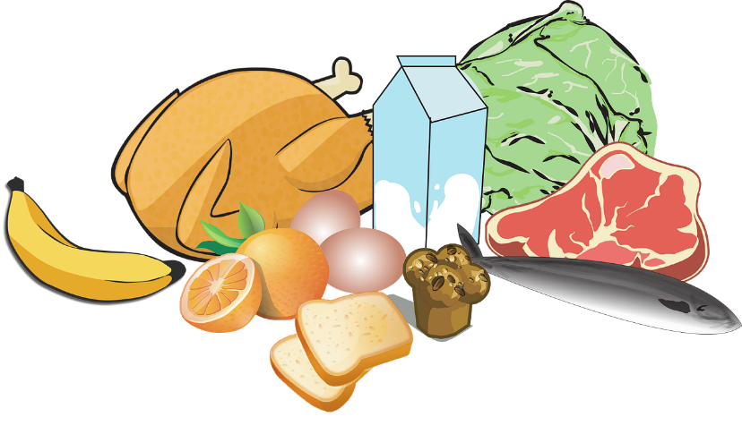
No, I don't like chips.

I like to eat healthy* food!
Not junk food!**

Do you like carrots?***
Yes, I like carrots.

Do you _______________ ?
Yes, I do.
No, I don't.

By _____ ________
* healthy: בריא
** junk food: אוכל לא בריא
*** carrot(s): גזר

