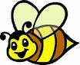
Rosh haShana

riddles - חידות

fish - pomegranate - shofar - honey - apple - card

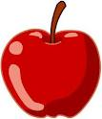
1. It is round and sweet. It can be red, green or yellow.
It is an __________________________
2. It is yellow and sweet. Bees make it.
It is __________________________
3. It is red and it has many seeds (גרעינים ).
It grows on a tree. It is a __________________________
4. We want to be like the head, not like the tail (זנב). It can swim.
It is a __________________________
5. It is the horn (קרן) of an animal. It is brown and we blow it.
It is a __________________________
6. We write this to friends and family.
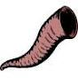
It is a __________________________
