What's The Time?

Draw the times on the clocks.
ציירו את השעה הנכונה בכל שעון.
- It's three o' clock.
- It's half past six.

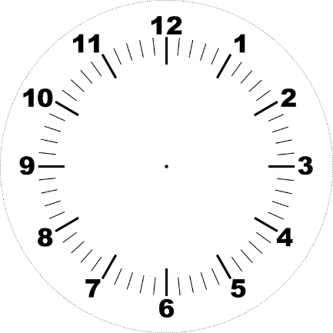

- It's half past seven.

- It's half past one.
- It's twelve o' clock.

