"To Be" Flashcard Practice

Print and cut out the cards below. There are a few ways to play:
- Hold up any of the subject+verb cards (in blue and red) and ask students what goes with what
- Ask students to match the correct adjective with the picture.
- At the end of the practice, only show pupils the card with subject and picture and/or adjective. Ask them to make complete sentences using the correct form of the verb ‘to be’ together with the green adjective cards.
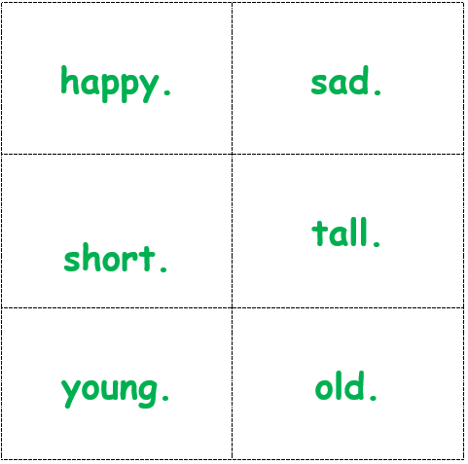
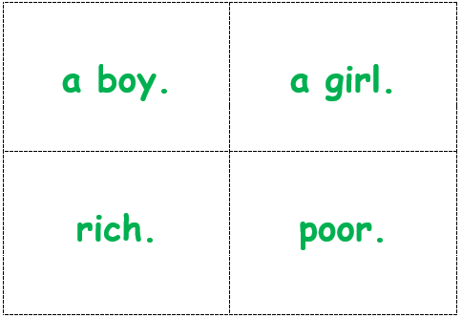
  I | am
  You | are
  He | is
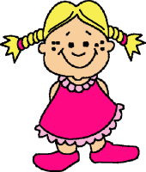  She | is
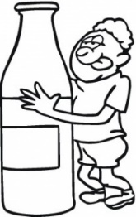  We | are
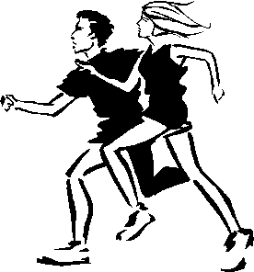  They | are
✂

