Listening Practice

Read the sentences below out loud to your students. Print this page for yourself and print the sentences with blanks (next page) for each student. Remember to read slowly and clearly! ☺

Fellow Copy

  - I have a pencil, scissors and glue.
  - I can see five chairs in the classroom.
  - We live in a big house with a garden.
  - What's the time? It's half past eight.
  - It's my birthday. I'm 10 years old.
  - We learn English every day.
  - My bedroom is clean and tidy.


הקשיבו למורה והשלימו את המילים החסרות.

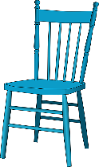
  - I have a _________, scissors and glue.

  - I can see __________ chairs in the classroom.

  - We ________ in a ________ house with a garden.
  - What's the _________? It's __________ past eight.


  - It's my ___________. I'm 10 _________ old.
  - We learn ____________ every day.
  - My bedroom is __________ and __________.



