My Home

Print the home worksheet below in color, if possible. Have students fill in the squares. They may be as creative as they like!
✂
השלימו את כל הפרטים בבית למטה.

My name:
My home



My favorite room is…

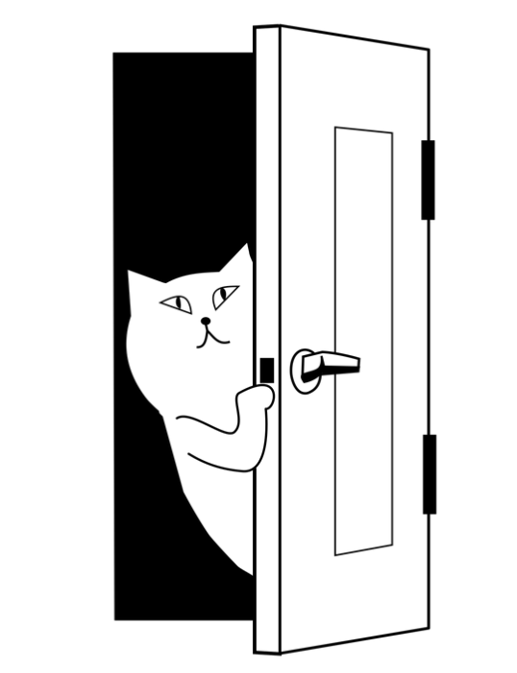

This is
me!

Address

