"Am, Is, Are" Video and Worksheet
Instructions:
- Print and cut the worksheet below for each student. Have them follow along with the video and pause to allow them time to write.
- First, play the video by following this link. If you prefer to open YouTube and find it manually, the video is called "Use of AM, IS, ARE with Pronouns | Grammar Grade 1 | Periwinkle".
- Play the video all the way through and have the students just listen.
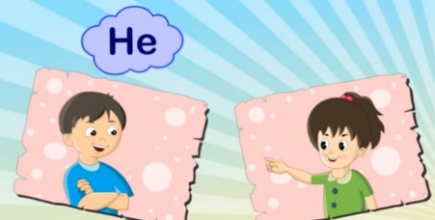
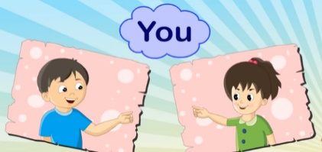
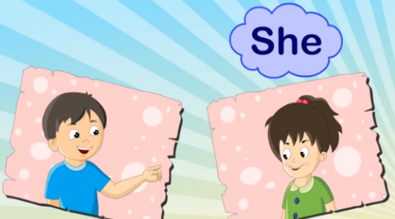
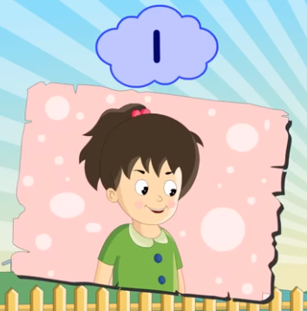
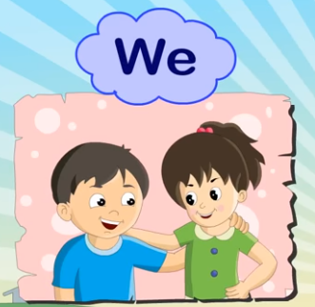
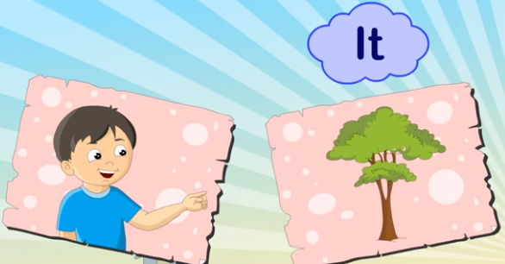
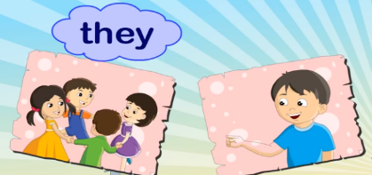
- After each pronoun is displayed in the video, pause the video so the students can fill in the blank.
It _________
2.
He _________
הוראות: הקשיבו לסרטון והשלימו את המשפטים. השתמשו ב- am are is.

3.
1.
We _________
She _________
5.
4.
7.
6.
They _________
I _________
You _________
It _________

