Our World – Find Out About Our World (Before You Start) Activities
5th Grade
Opening: Write the day and date on board. We suggest you start the session with a song or video. (see below) Fellows and students greet each other. Engage in a conversation with the students about some of these familiar topics.

- Fellow says: “Good morning/afternoon, students!”
  - Students say: Good …!
- Fellow says: “It’s nice to see you again.”
  - Students say: I'm glad to see you too. (Explain that glad means happy.)
- Fellow says: “Welcome to our lesson.”
- Fellow says: “My name is “…” “What’s your name?”
- Student says: “My name is “…” That student turns to next student and asks, “What’s your name?” The next student says… “My name is…” (Continue speaking and practicing names with each student in the group.)
- Fellow asks: “How are you? What’s new?”
  - Student says: I'm good/ I'm fine/ I'm all right
- Fellow asks: “How is your day?” Student says: It is good. / My day was great/fine.
- Fellow asks: What time is it?
  - Click here to access "What time is it?" song
- Fellow asks: “What day is today? What day was yesterday? What day will it be tomorrow?”
  - Days of the Week Rap:
  - Click here to access "Days of the Week Rap" Elementary
- Fellow asks: “What season are we in now?”
  - Click here to access song about the seasons Elementary
- Fellow asks: “What is the month?” Practice saying today is “…….” with students.
- Fellow asks: How’s the weather?
  - How's the weather? – Elementary song
  - Click here to access "How's the weather?" video
  - Students practice saying: It is cloudy/ it's rainy/ it's hot/ it’s nice/ sunny/ windy / cold / foggy…
- Fellow asks: “Are you ready to start our activities today?”
  - Students: “Yes!!”

Need help calming your students down? Try this: How to Calm Young Children Down in Minutes – Palming technique –Video: (This technique is for younger children, but it may still work for your group. Feel free to adapt it, if needed.)
- Click here to access: How to calm young children down in minutes

Objectives: In this unit, the students will practice:
- Simple letter sounds
- Colors
- Numbers

Puzzle Matching
Preparation: Cut out each rectangle and its matching side down the middle.
Play: Shuffle the card parts around on a table and have students match the sides of each rectangle by laying the pieces beside each other (matching the picture to its word).
כללי המשחק:
להרכיב משפטים נכונים כדי להתאים את התמונות. להניח את החלקים ליד התמונה.

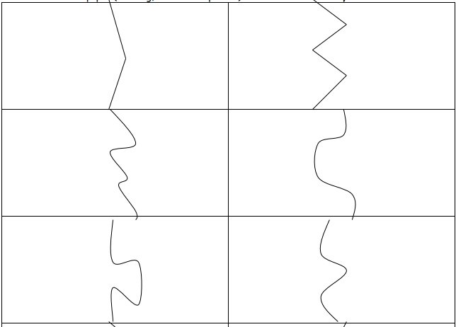
blue
red

yellow
green

orange
black

Note: For the color cards you may color the circles in with marker or colored pencils if you don't have access to a color printer.
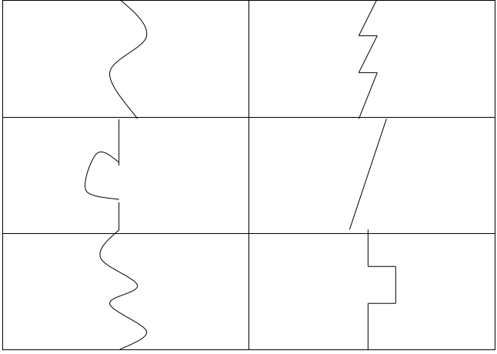

pink
purple

brown
white

two
2
8
eight

20
twenty
80
eighty
15
5
fifteen
five

60
16
sixty
sixteen

“Finger Twister” or “Finger Plonter פלונטר”
Directions for assembling the game: You will need a spinner, a “board” and cards. Print in color (if possible) and laminate (if possible) the following sheets:
- Finger Twister Board: The page with 4 columns of colored circles below with the category names.
- Spinner: The square with the colored circles all around; glue to a piece of cardboard or thick paper, insert a drawing pin in the center to hold the spinning arrow (also pasted to cardboard or other durable material.) Spinner can be reused with games containing other target material.
- Word cards: Cut out the Word Cards and place in four piles according to the categories:
“a” (red), “e” (yellow), “i” (green), and “o” (blue).
How to play and how to explain the game to the student:
This game is like “פלונטר”/Twister, except it’s for fingers – thumbs and middle fingers – instead of for hands and feet. There are 4 colors on the spinner and on the playing board. Each color is for words with a certain sound we have learned. Red is for “short a” words, yellow for “short e” words, green, for “short i” words and blue, for “short o” words.
I will spin the spinner. If it lands on blue, I’ll pick a card from the “o” pile. I’ll show it to you and you’ll read it. For example, it may be “box”. I’ll say either left thumb, or right thumb, or left middle finger, or right middle finger, depending on the spinner. You will put that finger on a circle in the row for the sound of the word: in this case it is an "o" word, so you put your finger on a blue circle.
Try not to pick up the finger that is on a circle until you need to move it to another circle. Once you have read 8 cards and gone to the correct color with the correct finger 8 times, you have won the game!
*If where you're teaching has a real “Twister” game and a large area in which to teach, you can play the real way. Small cards with the appropriate letter sounds can be “scotched” (with Velcro) onto the tops and bottoms of the colored circle columns.*

Finger Twister Board
"i"
"e"
"o"
"a"

category 4
category 1
category 2
category 3

Word cards for piles

cat | dog | red | sit
fat | jog | hen | swim
bad | hop | leg | in
sad | frog | egg | hit
tap | top | beg | big

Spinner

Finger Twister

Left thumb

Left middle finger

Right middle finger
Right thumb

Spinner Arrow to cut

(Thanks to Tamar Bernstein for the game template)
Closing: After each session before you say goodbye, ask students to reflect on the lesson.
- Fellow asks: What was fascinating/interesting about the lesson? What did you like?

- Ask each student to tell you 5 new English words they learned today.
  - Repeat the new words after the student says them. Then, repeat the new words with the student again so he/she practices English and learns the correct pronunciation.

- Ask: What is one question you still have about what you learned today?

- Ask: What would you like to learn more about?

Say goodbye to the students. Tell them you are looking forward to seeing them next time… Fellow says: Have a good day/afternoon… See you next time…

Name: _________________
Unit 1 Quiz
Part A
Color the flowers according to the teacher's instructions:
צבעו את הפרחים לפי הוראות המורה:
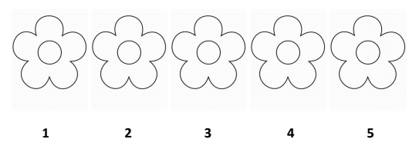

Part B
Complete the small letter:
השלימו את האות הקטנה:
A ___________

B ___________

G ___________

P ___________

E ___________

Part C
Write the name of the word under its picture. Use the word box:
כתבו את שם המילה מתחת לתמונה המתאימה. השתמשו במחסן המילים:









מחסן המילים
, sun, bus hat box, dog, stop,

Part D
Circle the number the teacher says:
הקיפו את המספר שהמורה מקריאה:
11 | 8 | 0 | 6
4 | 2 | 11 | 2
5 | 9 | 9 | 10
3 | 0 | 7 | 7
12 | 1 | 2 | 6

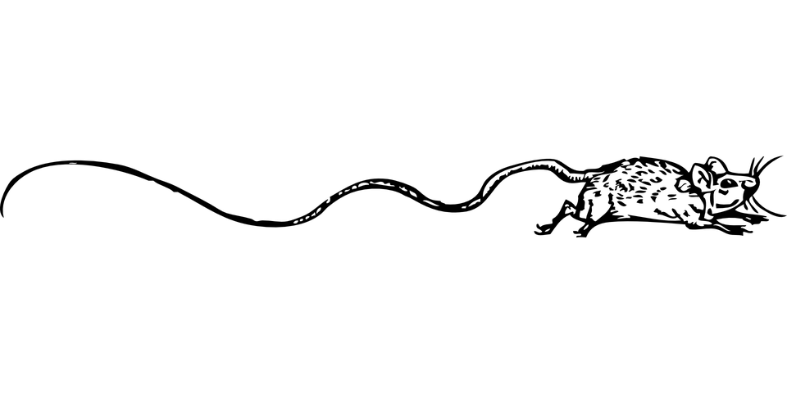
Part E
Circle the colors. After, color the pictures.
הקיפו את הצבעים. לאחר מכן, ציבעו את התמונות.
redyellowblueblackorangepinkgreenpurple

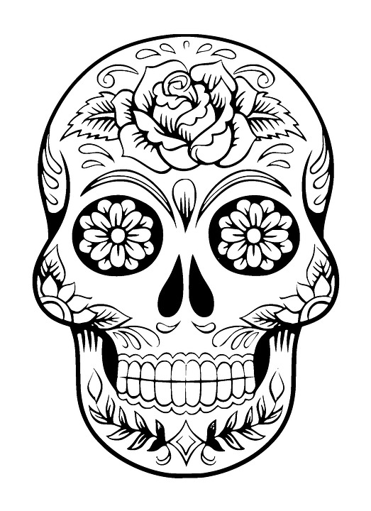

Quiz for Unit 1 – ANSWERS
Part A
Say these colors out loud:
YELLOW GREEN PINK PURPLE BROWN

Part B
Complete the small letter:
A _____a______
B _____b______
G ______g_____
P ______p_____
E _____e______

Part D
Circle the number the teacher says:
11 | 8 | 0 | 6
4 | 2 | 11 | 2
5 | 9 | 9 | 10
3 | 0 | 7 | 7
12 | 1 | 2 | 6
Say these numbers out loud: Zero, eleven, five, six, ten

