MY WEEKLY
FOOD JOURNAL
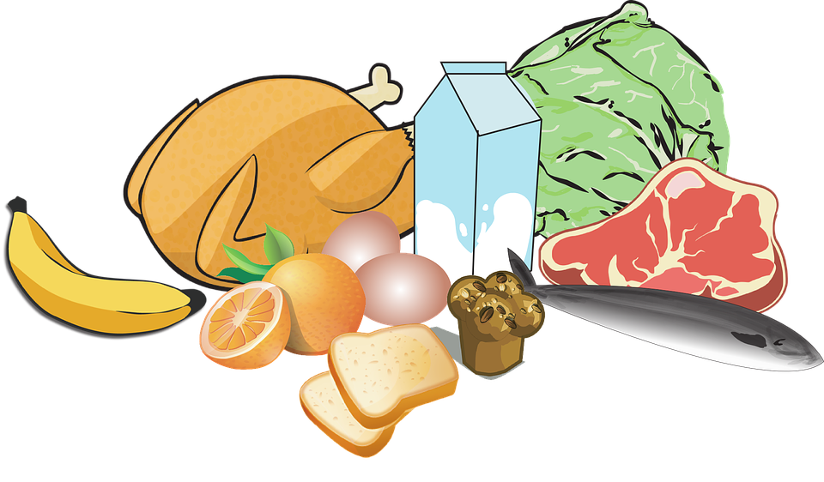

By ______
YEAR: _______

Sunday
- I have ______________________ for breakfast.
My brother/sister/father/mother has _________________ for breakfast.
- I have __________________ and_____________________ for lunch.
My brother/sister/father/mother has _____________and____________________ for lunch.
- I have __________________ and_____________________ for dinner.
My brother/sister/father/mother has _____________and____________________ for dinner.

Monday
- I have _________________ for breakfast.
My _________________ has _______________________ for breakfast.
- I have __________________and______________________ for lunch.
My _________________ has ___________________and__________________ for lunch.
- I have _________________ for dinner.
My _________________ has ___________________and__________________ for dinner.

Tuesday
- I have _________________ for breakfast.
My _________________ has _______________________ for breakfast.
- I have __________________and______________________ for lunch.
My _________________ has ___________________and__________________ for lunch.
- I have _________________ for dinner.
My _________________ has ___________________and__________________ for dinner.

Wednesday
_______________________________________________________________________________________________________________________________________________________________
_______________________________________________________________________________________________________________________________________________________________
_______________________________________________________________________________________________________________________________________________________________
_______________________________________________________________________________________________________________________________________________________________

Thursday
_______________________________________________________________________________________________________________________________________________________________
_______________________________________________________________________________________________________________________________________________________________
_______________________________________________________________________________________________________________________________________________________________

Friday
_______________________________________________________________________________________________________________________________________________________________
_______________________________________________________________________________________________________________________________________________________________
_______________________________________________________________________________________________________________________________________________________________
_______________________________________________________________________________________________________________________________________________________________

Saturday
_______________________________________________________________________________________________________________________________________________________________
_______________________________________________________________________________________________________________________________________________________________
_______________________________________________________________________________________________________________________________________________________________
_______________________________________________________________________________________________________________________________________________________________



