What are They Wearing?
1. Color the pictures.
צבעו את התמונה – כל פריט לבוש בצבע שונה.
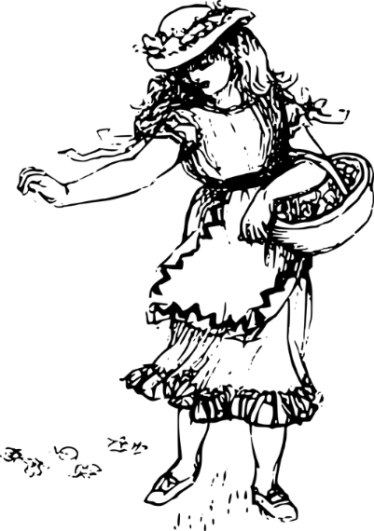
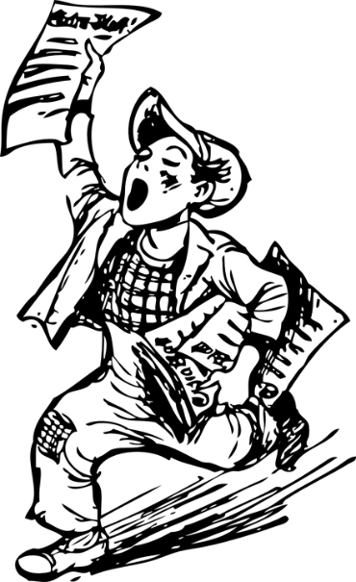
Ron

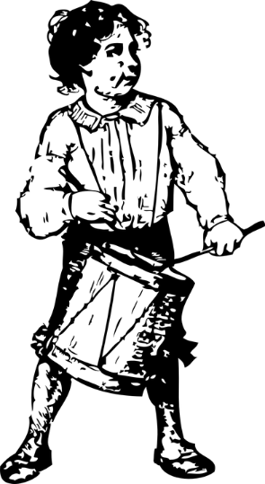
Dana
Tom

2. Write sentences. Use word/words from each group.
כתבו משפטים. השתמשו במילה/מילים מכל קבוצה.
dress  skirt  shoes  pant  shirt  jeans  socks  boots  hat  coat | red  yellow  green  gray  black  pink  brown  purple  blue  orange  white | is wearing a  is wearing | Ron  Tom  Dana

______________________________________________________________________________________________________________________________________________________________________________________________________________________________________________________________________________________________________________________________________________________________________________________________________________________________________________________________________________________________________________________________________________________________________________________________________________

