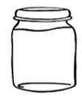
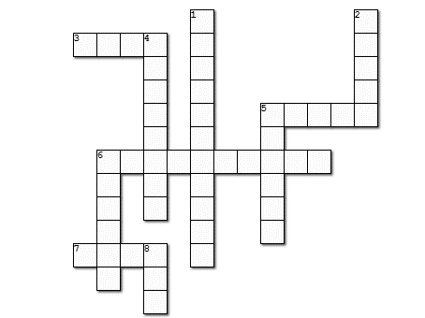
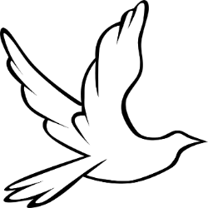
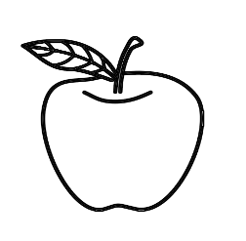
Down:
1. A red fruit filled with many seeds.
2. Dip the apple in _______.
4. There are three important ______ in Tishrei.
5. A ram's-horn "trumpet"
6. We eat in the _____ for seven days!
8. The number of days between Rosh Hashanah and Yom Kippur.
Across:
3. One of Rosh Hashanah symbols.
5. An expression of apology.
6. Greeting for the new year.
7. When you don't eat a whole day.
Tishrei Holidays

