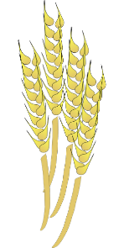
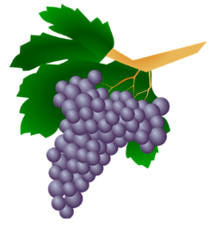
The Seven Species
Word Search
z j x s v g c j q i x h y e d
d q c o e t s v f p t l e i i
m w k p a t d m p n o v l g t
t z o e o e a o u d v n r f m
k o h l y y t n g j g r a p e
c w l b k m e b a m m k b b i
t o a i o t s q r r y w v u w
j p w u v p i v p i g x f m p
l n x r s e r v b i x e i d j
w h f x l y l r r t p o m e d
g i t p a e h e z q a r q o p
g u x o c v k i e p f w x p p
b b l r t n w l v q q w l b u
n n c d k d p w t c e c l y g
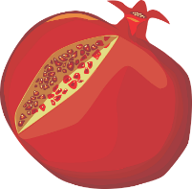
f d z y w k u q n h t g k u a

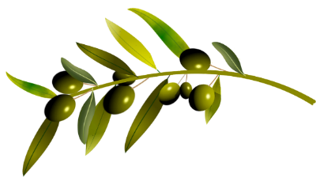
Word Bank: wheat, barley, grape, fig, pomegranates, olive, dates

