At School Vocabulary Practice Page
- Review the following words:
- חיזרו על המילים הבאות:

book | pen | pencil | notebook | glue
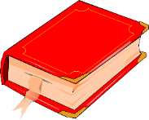 | 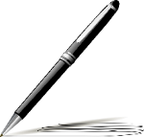 | 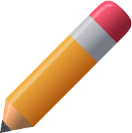 | 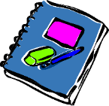 | 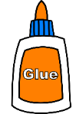
shelf | scissors | sandwich | pupil | teacher
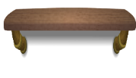 | 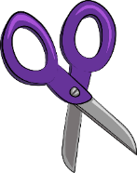 | 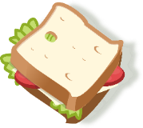 |  | 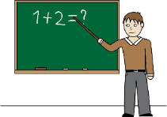

On my shelf

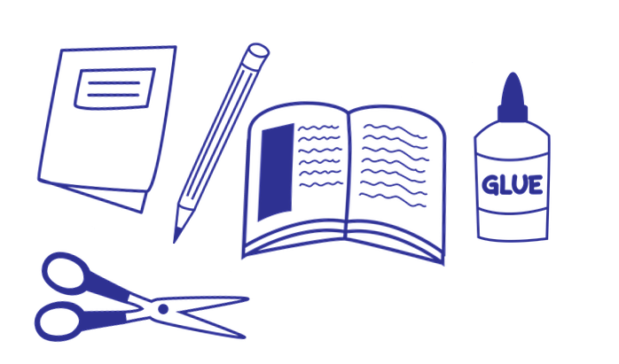
- Point on the item and say it together:

- Complete the sentences:

- The ____scissors____ are on my shelf.
- The ______________ is on my shelf.
- The ______________ is on my shelf.
- The ______________ is on my shelf.
- The ______________ is on my shelf.

