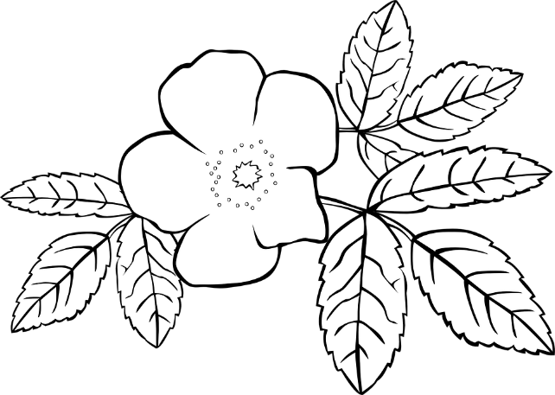
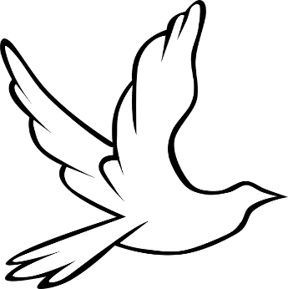
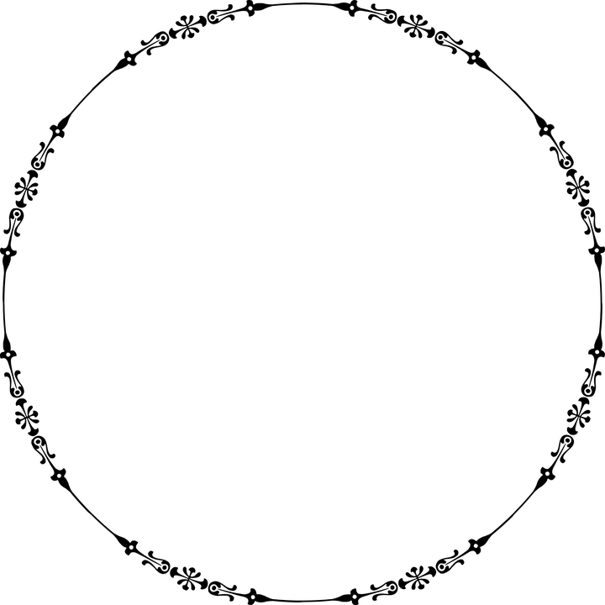
Yom Kippur
What do you think is the most important tradition on Yom Kippur? _______________________________________________________________________________________________________________________________________
________________
What do you do on Yom Kippur? _______________________________________________________________________________________________________________________________________
_____________________
What can we learn from Yom Kippur? _______________________________________________________________________________________________________________________________________

