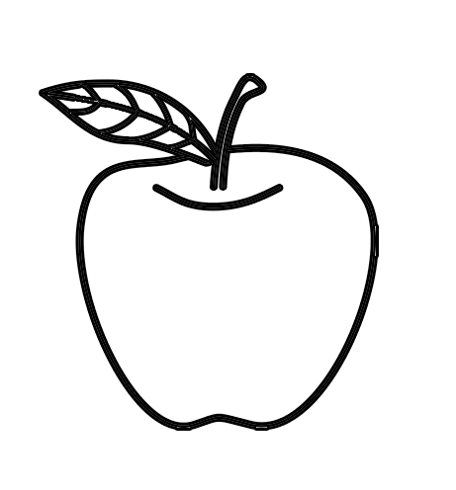
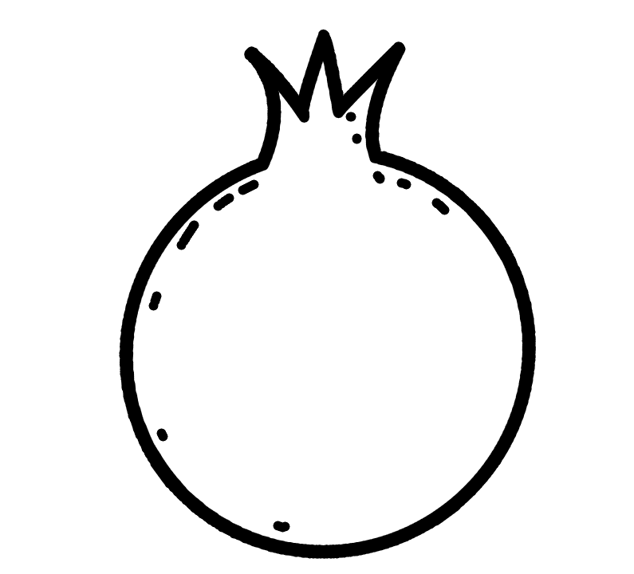
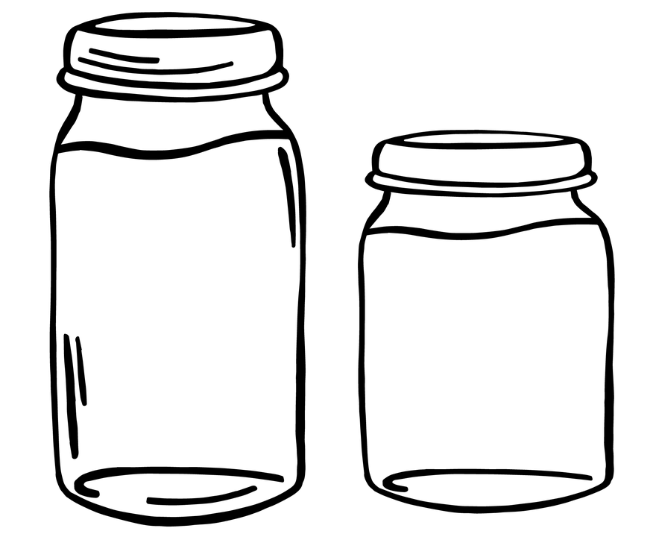
What do I wish myself for the new year? _____________________________________________________________________________________
____________

For the New Year

What do I wish for the people of Israel in the coming year?
_________________________________________________________________________________________
____________

What do I wish my family for this year?
__________________________________________________________________________________________________________

