Emoji Exit Ticket
Circle the emoji that best reflects how you feel about today's lesson.
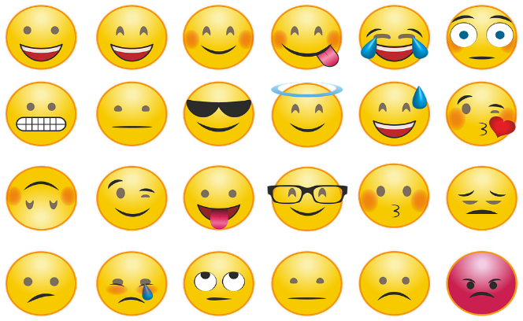
I chose _______________ because _____________
________________________________________.
Do you have any other questions? _______________
________________________________________.

Emoji Exit Ticket
Circle the emoji that best reflects how you feel about today's lesson.
I chose _______________ because _____________
________________________________________.
Do you have any other questions? _______________
________________________________________.

