Clothing Line
Follow the instructions below.
צבעו את הבגדים לפי ההוראות למטה.
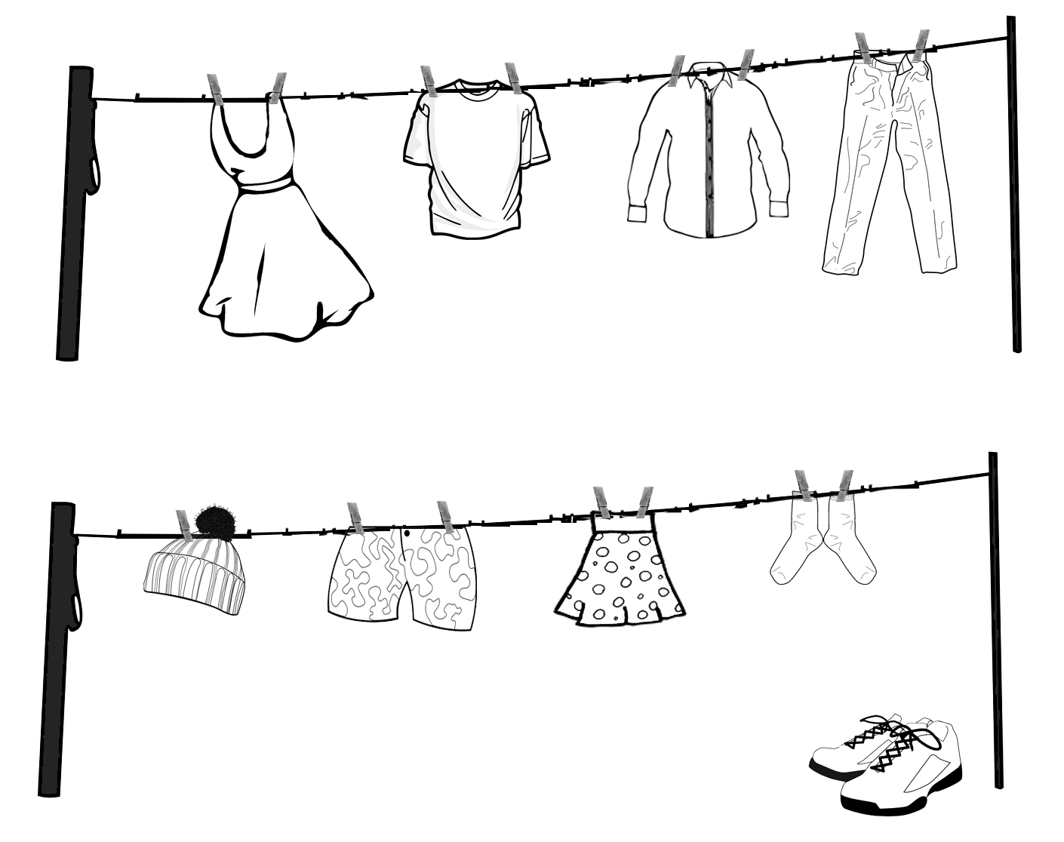

Color the t-shirt pink. | Color the socks green.
Color the skirt blue. | Color the pants yellow.
Color the shoes red. | Color the shirt purple.
Color the dress orange. | Color the hat black.
Color the shorts white.

