Rosh haShana
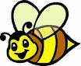

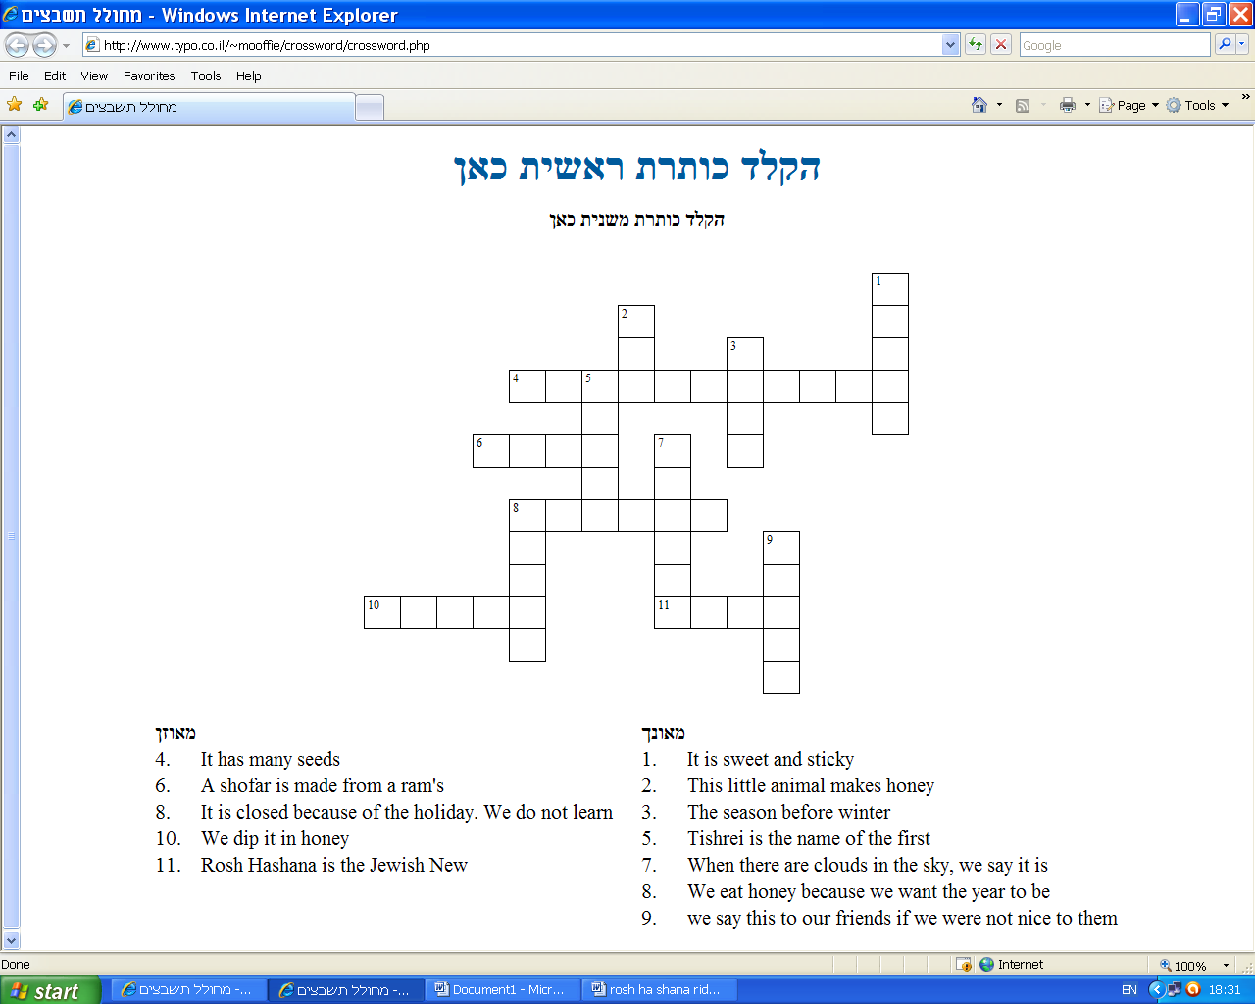
© Marion Golany

crossword


Horizontal
4. | It has many seeds.
6. | A shofar is made from a ram's ......
8. | It is closed because of the holiday. We do not learn.
10. | We dip it in honey.
11. | Rosh Hashana is the Jewish New ...........

Vertical
1. | It is sweet and sticky.
2. | This little animal makes honey.
3. | The season before winter.
5. | Tishrei is the name of the first Hebrew ..........
7. | When there are clouds in the sky, we say it is ..........
8. | We eat honey because we want the year to be ........
9. | We say this to our friends if we were not nice to them.

