Hey! – Student Book - 5th Grade
“Getting Started - Review” - Foundation Level
Opening: Write the day and date on board. We suggest you start the session with a song or video. (see below) Fellows and students greet each other. Engage in a conversation with the students about some of these familiar topics.

- Fellow says: “Good morning/afternoon, students!”
  - Students say: Good …!
- Fellow says: “It’s nice to see you again.”
  - Students say: I'm glad to see you too. (Explain that glad means happy.)
- Fellow says: “Welcome to our lesson.”
- Fellow says: “My name is “…” “What’s your name?”
- Student says: “My name is “…” That student turns to next student and asks, “What’s your name?” The next student says… “My name is…” (Continue speaking and practicing names with each student in the group.)
- Fellow asks: “How are you? What’s new?”
  - Student says: I'm good/ I'm fine/ I'm all right
- Fellow asks: “How is your day?” Student says: It is good. / My day was great/fine.
- Fellow asks: What time is it?
- Fellow asks: “What day is today? What day was yesterday? What day will it be tomorrow?”
  - Days of the Week Rap:
  - Click here to access "Days of the Week Rap" Elementary
- Fellow asks: “What season are we in now?”
  - Click here to access song about the seasons Elementary
- Fellow asks: “What is the month?” Practice saying today is “…….” with students.
- Fellow asks: How’s the weather?
  - How's the weather? – Elementary song
  - Click here to access "How's the weather?" video
  - Students practice saying: It is cloudy/ it's rainy/ it's hot/ it’s nice/ sunny/ windy / cold / foggy…
- Fellow asks: “Are you ready to start our activities today?”
  - Students: “Yes!!”

Need help calming your students down? Try this: How to Calm Young Children Down in Minutes – Palming technique –Video: (This technique is for younger children, but it may still work for your group. Feel free to adapt it, if needed.)
- Click here to access: How to calm young children down in minutes
_____________________________________________________________
Objectives: In this unit, the students will practice:
- speaking about animal vocabulary – nouns and verbs
- listening to a video for key details
- writing
- reading
- identifying
_____________________________________________________________
Please check all links and print out all materials ahead of class. This document has with many parts. It is suggested you read through the whole lesson and then decide which parts you will use with your students. Then collect the materials listed below for whichever lessons you choose.

Materials needed: colored pencils, half sheet of paper for each student, projector/screen to watch short YouTube video, all attachments printed out (animal vocabulary list, card game, bingo sheets, bingo markers…)
________________________________________________________________
Activity 1: Introduce the topic and write it as a title on the board – Field Trip to the Zoo

First, ask questions to students related to their background knowledge.

Remember:

- Speak slowly and increase your wait time for responses.
- Model and encourage students to speak in complete sentences.
- Teacher asks: Have you ever been to the zoo? (Yes I have been to the zoo./No, I’ve never been to the zoo...)
- Teacher asks: When was the last time you were at the zoo? (Model: I went to the zoo yesterday.)
- Write this sentence starter on the board: At the zoo I saw _______.
- Teacher says: “Turn to one person next to you and tell them which animals you saw.” –
- Give students a few minutes to question and answer each other.
_____________________________________________________________

Activity 2: Animals (Review) Vocabulary Introduction - Teacher introduces the vocabulary items.

Please write the words in the first column on the board, pronounce them, and ask the students to repeat after you.
Nouns – Print and give each student a copy of this vocabulary list:

bird | 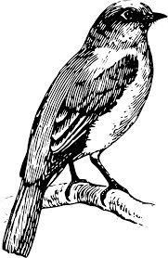 | ציפור | طائر
cat | 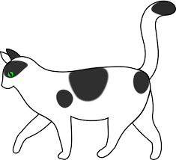 | חתול | قط
monkey | 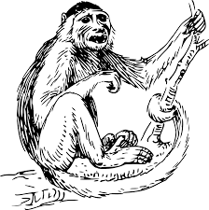 | קוף | قرد
elephant | 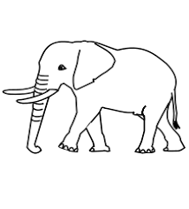 | פיל | فيل
kangaroo | 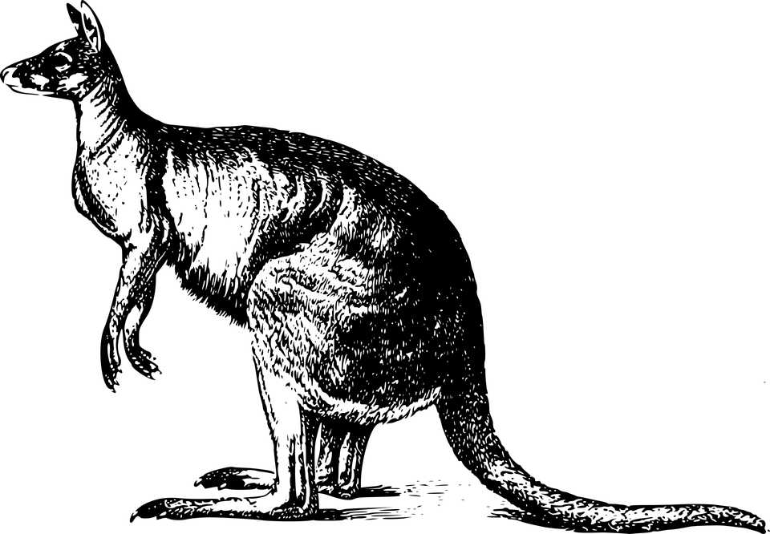 | קנגרו | كنغر
lion | 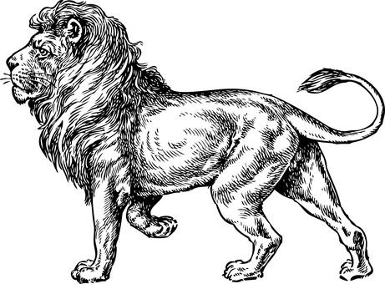 | אריה | سد
panda |  | פנדה | الباندا
penguin | 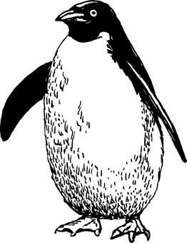 | פינגווין | البطريق طائر
rabbit | 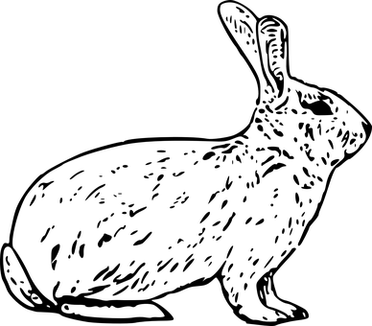 | ארנב | أرنب
zebra | 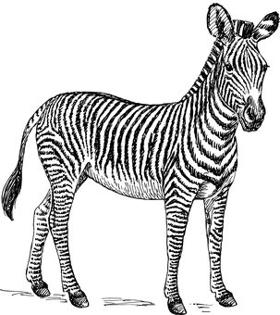 | זברה | الحمار الوحشي

Activity 3: Watch, speak, and listen - Watch the 2-minute video "Playful Panda Cub"
(Make sure to give students paper and something to write with.)

Click on the hyperlink: https://www.youtube.com/watch?v=cxda12m6bOc or type in the title of the video in YouTube.

- Before viewing the video, tell students that while they are watching the video, they need to write down at least two actions of the panda.

Examples: The panda… sits, eats, stands, climbs, jumps… (use present tense/past tense verbs)

2. Write and review 7 verbs on the board and say each word out loud. Tell students to
act out each action as you say each word. Tell students you will ask them to tell
you what actions they saw the pandas do and what they wrote down after the video.

Verbs - Present tense/past tense verbs
- sit/sat
- eat/ate
- drink/drank
- climb/climbed
- run/ran
- jump/jumped
7. sleep/slept

Note: Practice creating other sentences using these verbs. Encourage students to speak in complete sentences. Model speaking in a complete sentence.

Examples: The student jumps. The teacher climbs a tree. The boy eats leaves.

3. After watching the video, ask students to turn to their partner and ask what
else they noticed about the pandas and their habitat (where they live)…

Examples: Students identify characteristics/adjectives (The pandas are playful, energetic, happy), colors (The pandas have black and white fur, live near green leaves…)
____________________________________________________________
Activity 4 – Practice Speaking – Dialogue Activity
Students write answers to these questions and then ask each other these questions and/or take turns speaking their answers to the whole class.

Questions are listed below. Print them out or write them on the board.

- Who would you invite to go to the zoo with you? Why?
- Which animal would you like to see first? Why?
- What is your favorite animal? Why?
- What do you think is the most dangerous animal in the zoo? Why:
- Which animal do you think is the most gentle? Why?
- Do you think animals are important? Why or why not?

Activity 5 - Animal Cards - Go Fish Game and/or Animal Bingo Game
Students play games to reinforce vocabulary.

Students play Card Game (Animal Go Fish). See activity directions attached:

Animal Cards - Go Fish Game link:
https://drive.google.com/file/d/1zAcgYeFkM5VJnbviSUTbgcoZ2qp-kzpP/view?usp=sharing
and/or

The teacher calls out the names of animals for Bingo. See activity directions attached:

Animal Bingo Game link: https://drive.google.com/file/d/1zAcgYeFkM5VJnbviSUTbgcoZ2qp-kzpP/view?usp=sharing
_______________________________________________________
During this unit, students:
- practiced speaking reading writing listening
- reviewed
- created
_____________________________________________________________________
Closing: After each session before you say goodbye, ask students to reflect on the lesson.
- Fellow asks: What is one thing you liked about the lesson?

- Ask each student to tell you 3-5 new English words they learned today.
  - Repeat the new words after the student says them. Then, repeat the new words with the student again so he/she practices and learns the correct pronunciation.

- Ask: What is one question you still have about what you learned today?

- Ask: What would you like to learn more about?

Say goodbye to the students. Tell them you are looking forward to seeing them next time… Fellow says: Have a good day/afternoon… See you next time…

