English Word | Hebrew/Arabic
1. example: word | 1. לדוגמה: מִלָּה
2. | 2.
3. | 3.
4. | 4.
5. | 5.
6. | 6.
7. | 7.
8. | 8.
9. | 9.
10. | 10.

Flashcards template for the instructor’s use. You can use the following template to present new vocabulary words to your group.

Flashcards template for the students’ use. The students can use the following cards to practice the new vocabulary and/or play with them. You/They can write the translation on the back of each card.

Insert text here

Insert text here

Flashcards template for student use. The students can use the following cards to practice the new vocabulary and/or play with them. You can write the translation on the back of each card.
Optional: You can also play a memory game with these cards by matching English word to translation and/or picture.

Game Templates
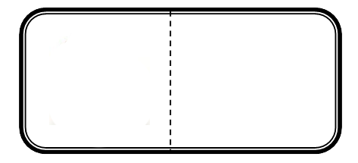
Dominoes:

[insert word 1]
[insert picture 3]

[insert word 2]
[insert picture 4]

[insert word 10]
[insert picture 2]

[insert word 9]
[insert picture 1]

[insert word 8]
[insert picture 10]

[insert word 7]
[insert picture 9]

[insert word 6]
[insert picture 8]

[insert word 5]
[insert picture 7]

[insert word 4]
[insert picture 6]

[insert word 3]
[insert picture 5]

Bingo Template

5-minute Bingo

