Adjectives Worksheet
Describe the people below (thin, young, old, fat) and match the opposites.

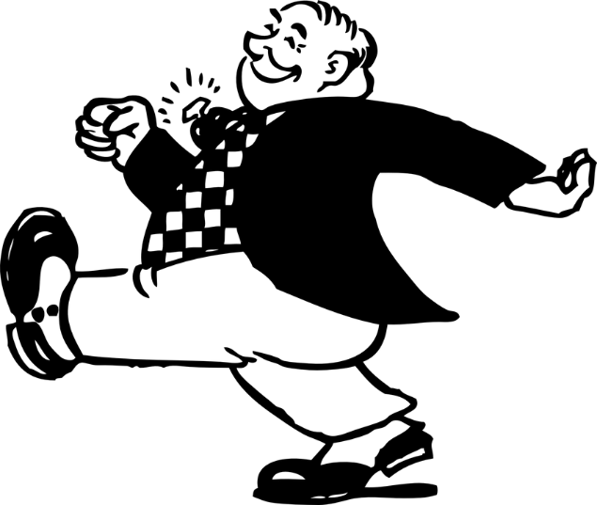
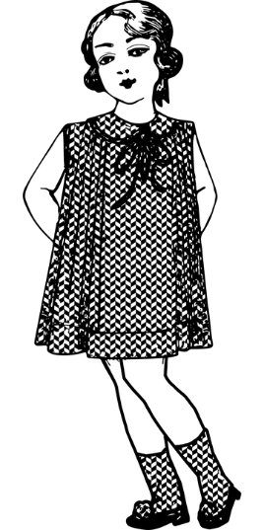

The man is ____________.

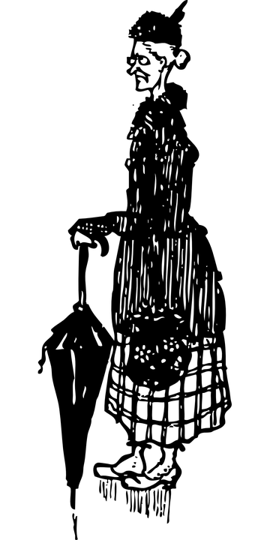

The girl is ____________.
The man is ____________.
The woman is ____________.

