Clothing Vocabulary Practice Page
- Review the following words:
- חיזרו על המילים הבאות:

dress | skirt | sweater | jeans | jacket
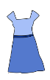 | 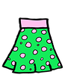 | 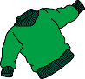 | 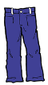 | 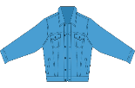
shirt | coat | umbrella | shoes | boots
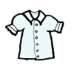 |  | 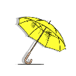 | 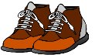 | 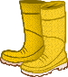
Dress the Snowman!
- Draw clothes on the snowman and write what he’s wearing:
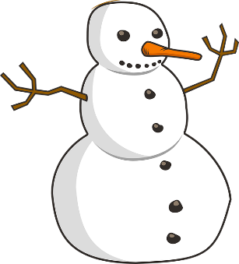
- ציירו בגדים לאיש השלג וכיתבו מה הוא לובש:
My snowman is wearing:
________________________________________________________________________________________________________________________________________________________.

