Clothing Vocabulary Practice Page
- Review the following words:
- חיזרו על המילים הבאות:

dress | skirt | sweater | pants
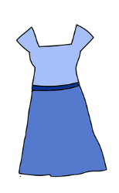 | 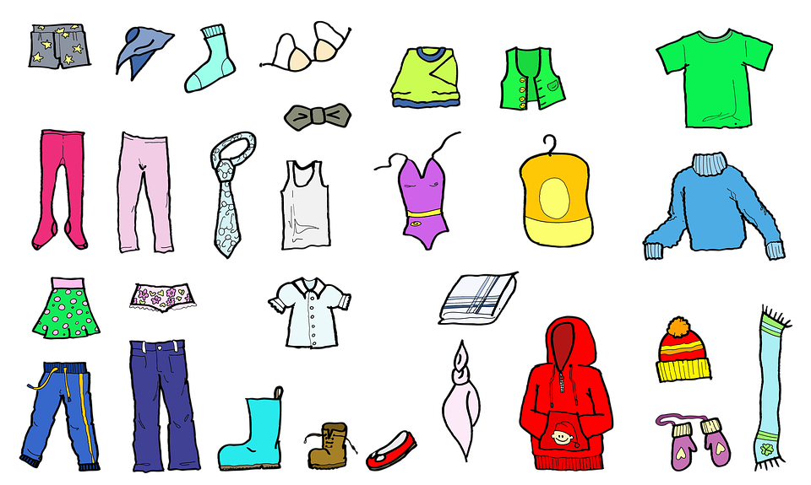 | 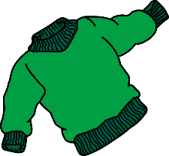 | 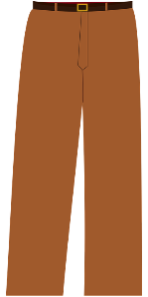
shirt | coat | umbrella | shoes
 | 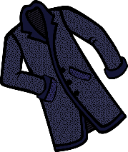 | 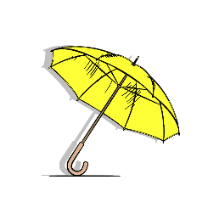 | 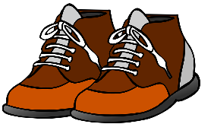
jacket | boots | scarf | hat
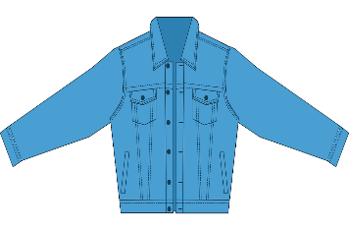 | 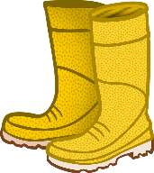 |  | 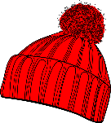
jeans | swimsuit | pajamas | socks
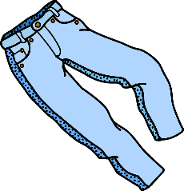 |  |  | 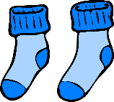

Dress the Snow People!
- Draw clothes on the snow people and write what they are wearing:
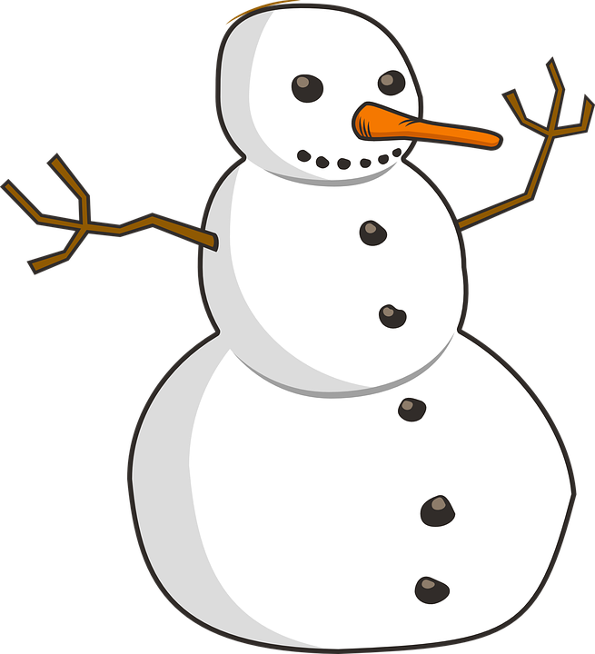
- ציירו בגדים לאיש השלג וכיתבו מה הוא לובש:
My snowwoman is wearing:
________________________________________________________________________________________________________________________________________________________.
My snowman is wearing:
________________________________________________________________________________________________________________________________________________________.

