All About Me Worksheet
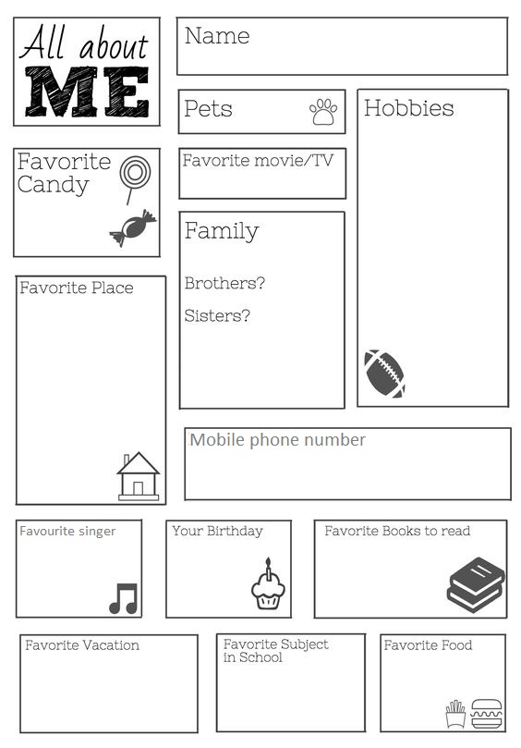
Print and cut out the worksheet below for each student and have them fill out their personal details. Students may draw pictures if they choose.



Pets?
I am
________ years old.



I live at



Telephone number

Favorite animal
My birthday
My mom's e-mail




Favorite food
Favorite song
