Click 3 – Unit 1 Click on English Activities
3rd Grade

Opening: Write the day and date on board. We suggest you start the session with a song or video. (see below) Fellows and students greet each other. Engage in a conversation with the students about some of these familiar topics.
· Fellow says: “Good morning/afternoon, students!”
o Students say: Good …!
· Fellow says: “It’s nice to see you again.”
o Students say: I'm glad to see you too. (Explain that glad means happy.)
· Fellow says: “Welcome to our lesson.”
· Fellow says: “My name is “…” “What’s your name?”
· Student says: “My name is “…” That student turns to next student and asks, “What’s your name?” The next student says… “My name is…” (Continue speaking and practicing names with each student in the group.)
· Fellow asks: “How are you? What’s new?”
  - Student says: I'm good/ I'm fine/ I'm all right
· Fellow asks: “How is your day?” Student says: It is good. / My day was great/fine.
· Fellow asks: What time is it?
  - Song for young kids with body movements:
  - Click here to access "What time is it?" song
· Fellow asks: “What day is today? What day was yesterday? What day will it be tomorrow?”
  - Click here to access "Days of the Week" song Early Elementary
· Fellow asks: “What season are we in now?”
o Click here to access "If you know all the seasons, clap your hands... Song Early Elementary
· Fellow asks: “What is the month?” Practice saying today is “…….” with students. Elementary and Young Juniors
· Fellow asks: “How’s the weather?” Early Elementary song:
  - Click here to access "How's the Weather?" video
o Students practice saying: It is cloudy/ it's rainy/ it's hot/ it’s nice/ sunny/ windy / cold / foggy…
· Fellow asks: “Are you ready to start our activities today?”
  - Students: “Yes!!”

Need help calming your students down? Try this: How to Calm Young Children Down in Minutes – Palming technique – Early Elementary (grades 1-4) Video:
o Click here to access: How to calm young children down in minutes

Objectives: In this unit, the students will practice:
- Vocabulary related to the Internet and e-mail
- Constructing basic sentences

Write the words under each picture.
כיתבו את המילים מתחת לתמונות המתאימות.

grade ● English ● e-mail ● name ● boy ● girl
computer ● telephone

שם
אנגלית

………
………
name
………

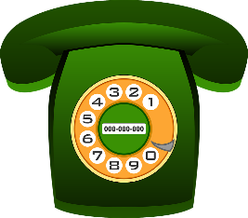

כיתה

………
………
………




………
………

All About Me Worksheet
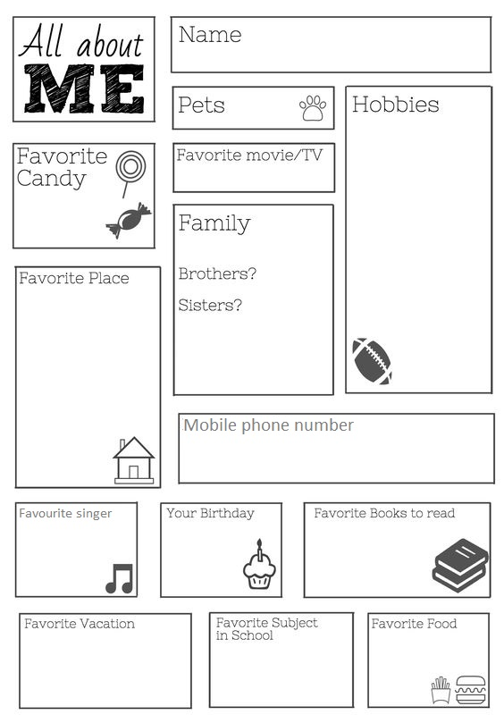
Print and cut out the worksheet below for each student and have them fill out their personal details. Students may draw pictures if they choose.



Pets?
I am
________ years old.



I live at
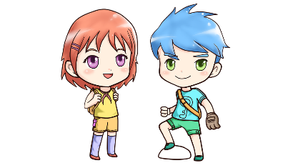


Telephone number

Favorite animal
My birthday
My mom's e-mail




Favorite food
Favorite song
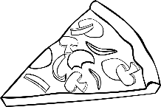


Read the e-mail. Complete the form.
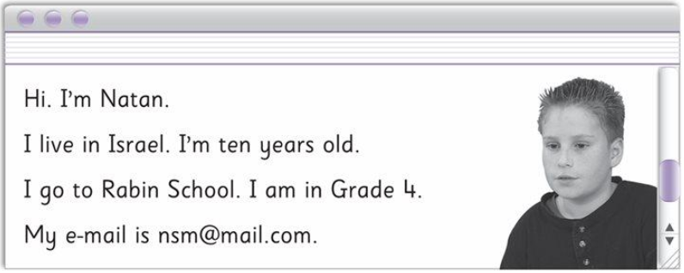
קיראו את האימייל ומלאו את הטופס.




Name:
Boy / Girl:
I live in:
E-mail:
School:
Grade:

During this unit, students:
- Wrote the time on analog clocks
- Started reading slighter longer passages

Closing: After each session before you say goodbye, ask students to reflect on the lesson.
· Fellow asks: What is one thing you liked about the lesson?
· Ask each student to tell you 3 new English words they learned today.
o Repeat the new words after the student says them. Then, repeat the new words with the student again so he/she practices and learns the correct pronunciation.
· Ask: What is one question you still have about what you learned today?
Say goodbye to the students. Tell them you are looking forward to seeing them next time… Fellow says: Have a good day/afternoon… See you next time…

Unit 1 Quiz
Part A
Read and tick the correct sentence.
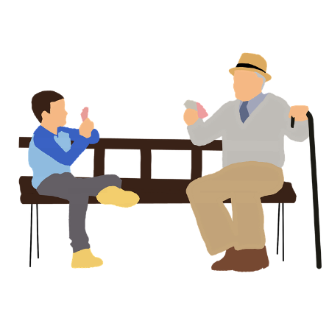
קרעו וסמנו ב- ✔ את המשפטים הנכונים.


The boys play basketball. ………
The boys play football. ………
The grandpa and the boy play cards. ………
The grandpa and the boy play on the computer. ………



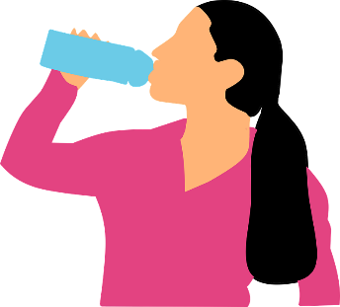

I talk to my friends. ………
I talk to my teacher. ………
I eat at 10 o' clock. ………
I drink at 10 o' clock. ………

Part B
Draw the times on the clocks.
ציירו את השעה הנכונה בכל שעון.

- It's three o' clock.
- It's half past six.

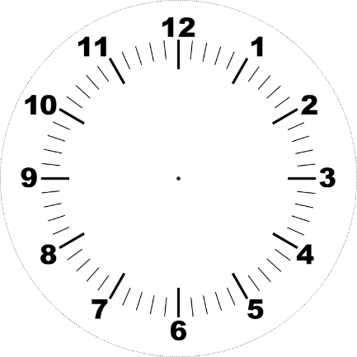

- It's half past seven.

- It's half past one.
- It's twelve o' clock.

Part C
Write a suitable verb.
כיתבו את הפועל המתאים כדי להשלים את צירופי המילים.

eat ● drink ● play ● go

play
….…….
….…….

….…….
….…….

Write sentences about what you do. (from Part C)
כיתבו משפטים על הדברים שאתם עושים. השתמשו בצירופי מילים מהתרגיל למלה. (מחלק C)
I play basketball.

- …………………………………………………………………………………………………………………………………………………

- …………………………………………………………………………………………………………………………………………………

- …………………………………………………………………………………………………………………………………………………

