Click 3 – Opening Unit (Check Your Reading) Activities
3rd Grade

Opening: Write the day and date on the board. We suggest you start the session with a song or video (see below). Teacher and students greet each other. Engage in a conversation with the students about some of these familiar topics.

- Welcome to our lesson.
- Good afternoon, students!
Good afternoon, teacher!
- It’s nice to see you again.
I'm glad to see you too. (Explain that glad means happy.)
- How are you? What’s new?
I'm good/ I'm fine/ I'm all right
- How was your day?
It was good/ It was great/fine
- What time is it now?
- What day is today? What day was yesterday? What day will it be tomorrow? https://www.youtube.com/watch?v=h84PF1zocdQ https://www.youtube.com/watch?v=7AvNq2CQnOI
or
- What season are we in now? https://www.youtube.com/watch?v=rZ6NJWNzBqE
- What is the month? Month video: https://www.youtube.com/watch?v=rZ6NJWNzBqE
- What’s the weather like today? https://www.youtube.com/watch?v=rD6FRDd9Hew or https://www.youtube.com/watch?v=CXKj7bm4Ops
It is cloudy/ it's rainy/ it's hot/ it’s nice/ sunny/ windy
- Are you ready to start our activities today?
Yes!!

Objectives: In this unit, the students will practice:
- Vocabulary acquisition
- Word/letter combinations (digraphs)

Review (חזרה)
Complete the words with th, sh or ch
השלימו את המילים עם th, sh או ch




th
………icken
………ree
bea………


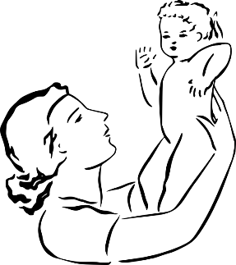


mo………er
………ocolate

………op




mou………
tea………er

………oes

Circle the word that doesn't rhyme in each row.
הקיפו את המילה בכל שורה שלא מתחרזת.
- wish ● fish ● dish ● wash
- make ● back ● cake ● snake
- hot ● boy ● joy ● toy
- gray ● day ● my ● play

Color the flowers with the same vowel sounds.
צבעו את הפרחים שיש להן אותה אם קריאה כמו במילה שמתחת לעציצים.
not

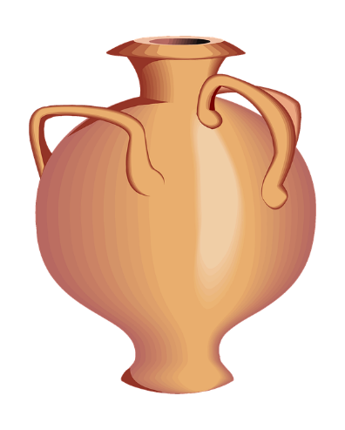
hat

drum
bus
rod
dot
bad
bag
red
fun
ten
rug
dad

shop

Write the missing letters.
כיתבו את האותיות החסרות באלפבית.
A__ B__ __c Dd E__
__ __ __g Hh I__ __j K__
L__ __m Nn O__ __p
Q__ __ __ S__ __t U__
V__ __ __ __x Y__ Zz

a

Circle the words that begin with the letter in each box.
הקיפו את התמונות שמתחילות באות שבתחילת כל שורה.



400
ורוד
f
1.

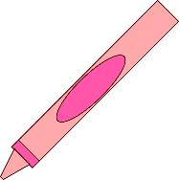
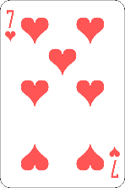
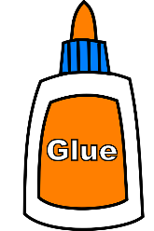


c
2.



7
s
3.
g
4.


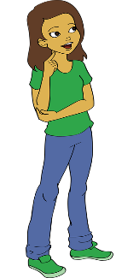
ורוד
ירוק

Complete the words. Highlight the long a sound.
השלימו את המילים. הדגישו את האותיות בכל קבוצה שנשמעות כמו השם של האות a.
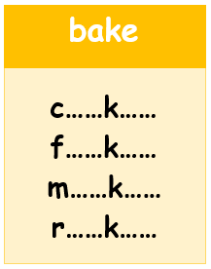
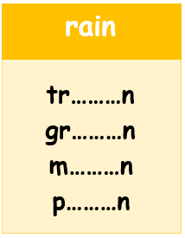
day
ay
pl………
w………
h………
p………

During this unit, students:
- Practiced word sounds TH, SH, and CH along with the "f, c, g, s & a" sounds
- Became familiar with rhyming words in English
- Reviewed the alphabet
Closing: Reflect on the lesson.
- For younger students, ask one thing they liked about the lesson.
- What new thing did they learn?
- For older students, ask what was special about the lesson.
- What is one question they still have?
- What would they like to learn more about?

Say goodbye to students. Tell them you are looking forward to seeing them next time… Have a good afternoon…

