Read and Match
Instructions: Match the pictures to the correct sentences.
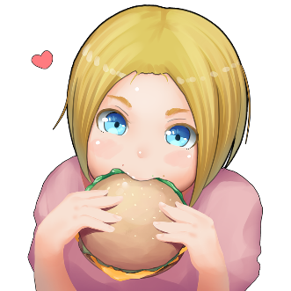
התאימו את המשפטים לתמונות.
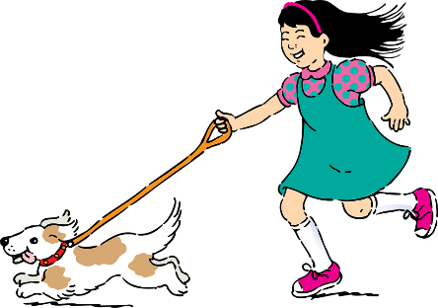
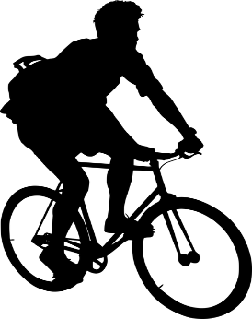
a

b
c

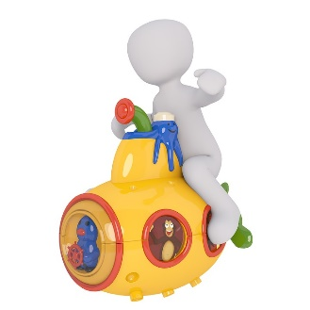
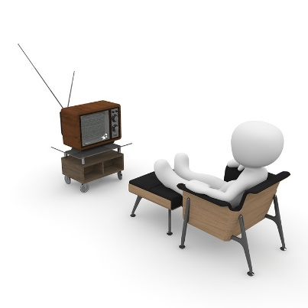
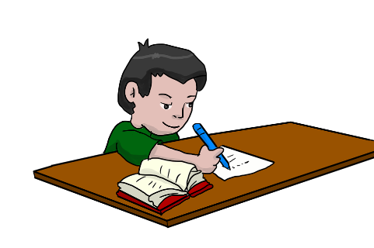
e
d

f

I eat a hamburger. …………… I watch TV. ……………

I play with my boat. …………… I run with my dog. ……………

I ride my bike to school. ……………

I read and write. ……………

