Unit 2 Quiz – ANSWERS
Part A
Match column A to column B according to the proper activities associated with each verb.
A B
c
watch …………… a. a game
d
ride …………… b. a book
e
climb …………… c. TV
a
play …………… d. a bike
b
read …………… e. a rope

Part B
Circle the words and write them under their matching picture.
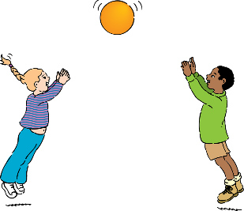
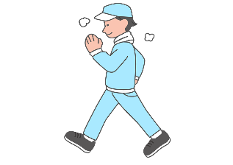
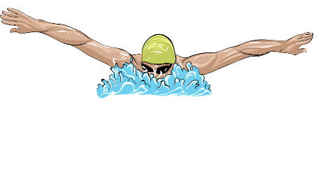
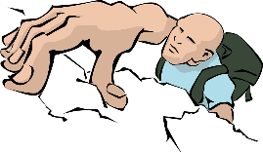
play
climb
walk
swim
……………

……………

……………

……………

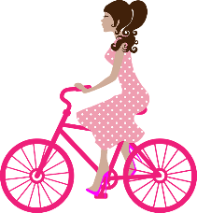

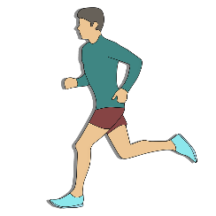

……………

read
run
ride
……………

watch
……………

……………

Part C
Circle the correct word according to its word/letter sound combination.
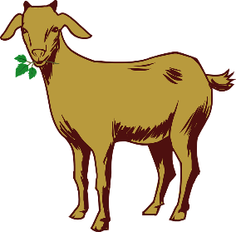
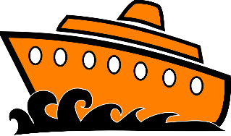
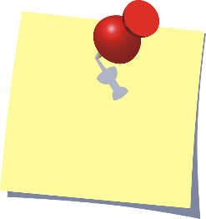


boot
boat
goat
got
not
note
home
hom

Part D
Write the words with the same word/letter sound combination in their suitable column.
cake jeans goat ride
boat tea face meat
snake five coat bike
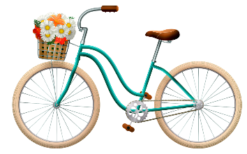 | 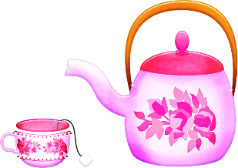 | 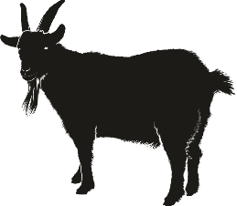 | 
bike | tea | goat | cake
ride | jeans | coat | snake
five | meat | boat | face

