Click 2 Unit 1 - Food Activities
3rd Grade

Opening: Write the day and date on the board. We suggest you start the session with a song or video (see below). Teacher and students greet each other. Engage in a conversation with the students about some of these familiar topics.

- Welcome to our lesson.
- Good afternoon, students!
Good afternoon, teacher!
- It’s nice to see you again.
I'm glad to see you too. (Explain that glad means happy.)
- How are you? What’s new?
I'm good/ I'm fine/ I'm all right
- How was your day?
It was good/ It was great/fine
- What time is it now?
- What day is today? What day was yesterday? What day will it be tomorrow? https://www.youtube.com/watch?v=h84PF1zocdQ https://www.youtube.com/watch?v=7AvNq2CQnOI
or
- What season are we in now? https://www.youtube.com/watch?v=rZ6NJWNzBqE
- What is the month? Month video: https://www.youtube.com/watch?v=rZ6NJWNzBqE
- What’s the weather like today? https://www.youtube.com/watch?v=rD6FRDd9Hew or https://www.youtube.com/watch?v=CXKj7bm4Ops
It is cloudy/ it's rainy/ it's hot/ it’s nice/ sunny/ windy
- Are you ready to start our activities today?
Yes!!

Objectives: In this unit, the students will practice:
- Vocabulary acquisition
- Word/letter combinations (digraphs)
- Listening

Dominoes
Print the domino cards below. You can have each child play by themselves or split the students into groups of four or less.

Instructions: Lay out one domino from the set and match the picture side to its appropriate word or match the word side to its appropriate picture. Continue laying out dominoes until every domino is correctly matched. You may turn corners when you run out of room.

כללי המשחק: קחו את כרטיסי הדומינו והניחו על השולחן. אחר כך, התאימו את התמונה לפירוש המתאים .המשיכו עד שנגמרים הקלפים. ניתן לשנות כיוון.

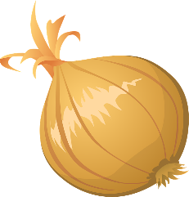
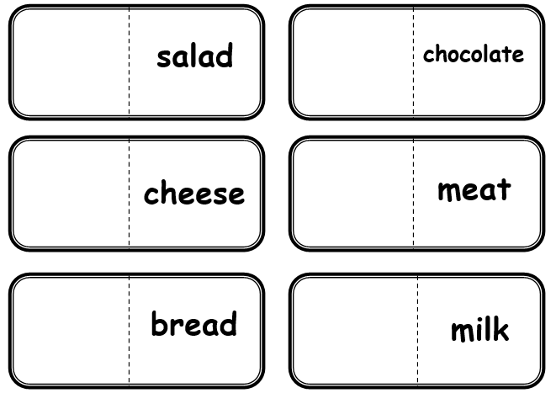
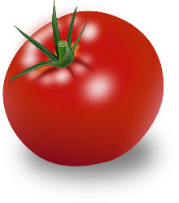


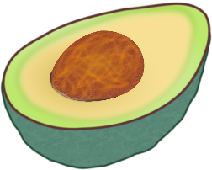

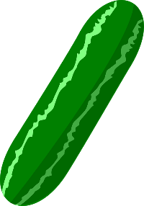

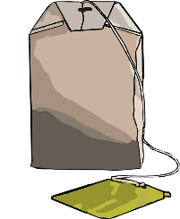

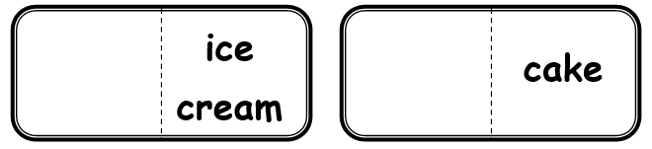
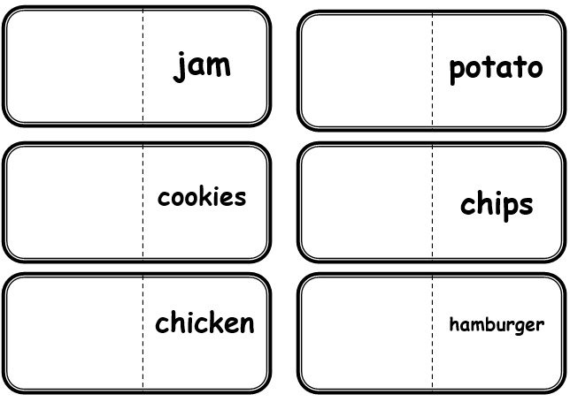

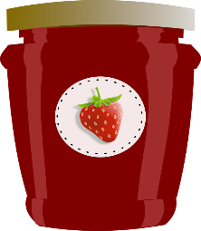


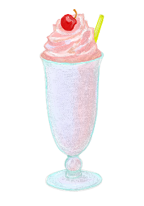

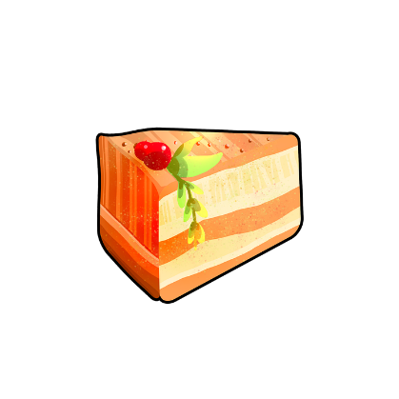


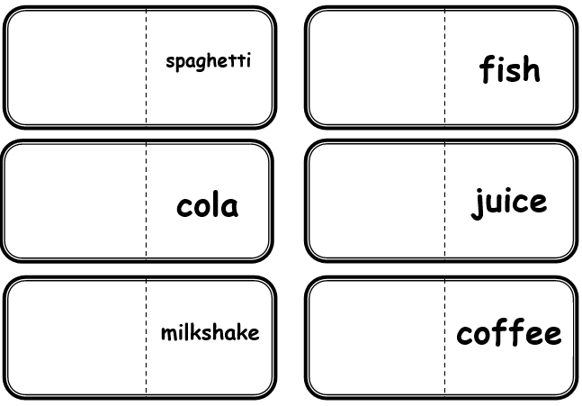
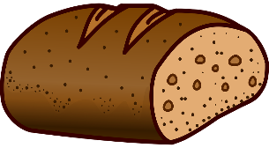
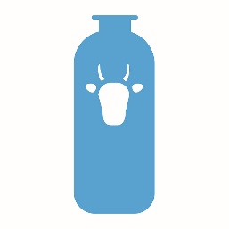

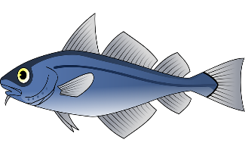
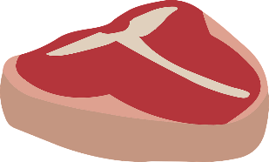
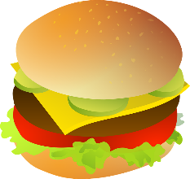
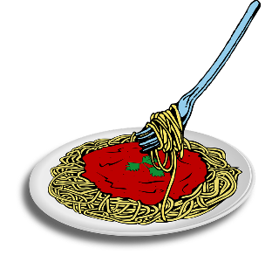
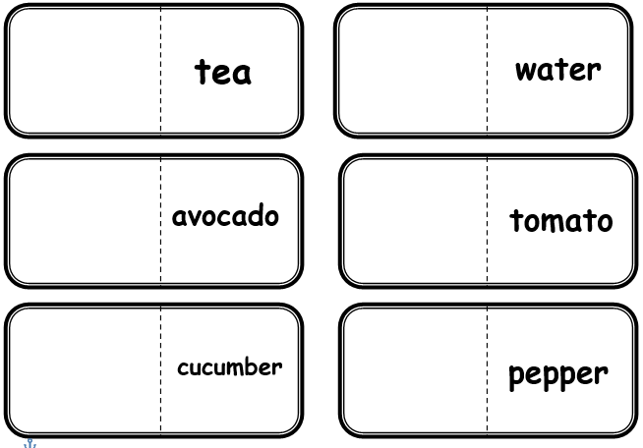
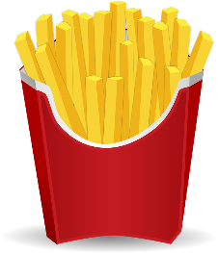


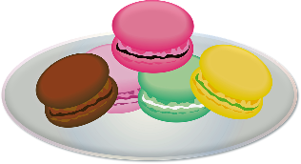
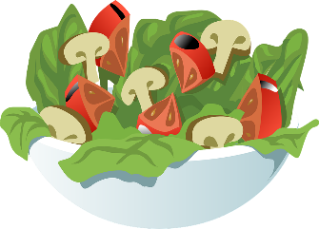
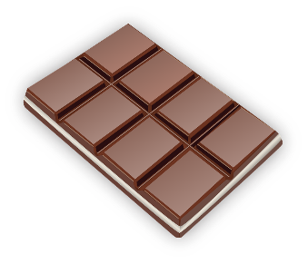
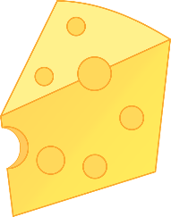

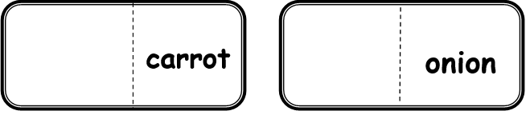
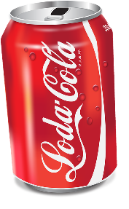
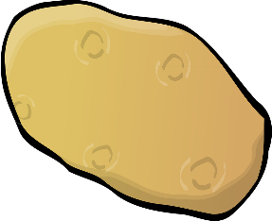

I Like… Don't Like…
Cut out the food chart at the bottom of this page. Place each food item you like under the "I Like" column and foods that you don't like under the "I Don't Like" Column.
גזרו את הריבועים מלמטה והניחו או הדביקו בעמודות מה שאוהבים לאכול ומה שלא אוהבים לאכול.
I Like אני אוהב(ת)
I Don't Like אני לא אוהב(ת)



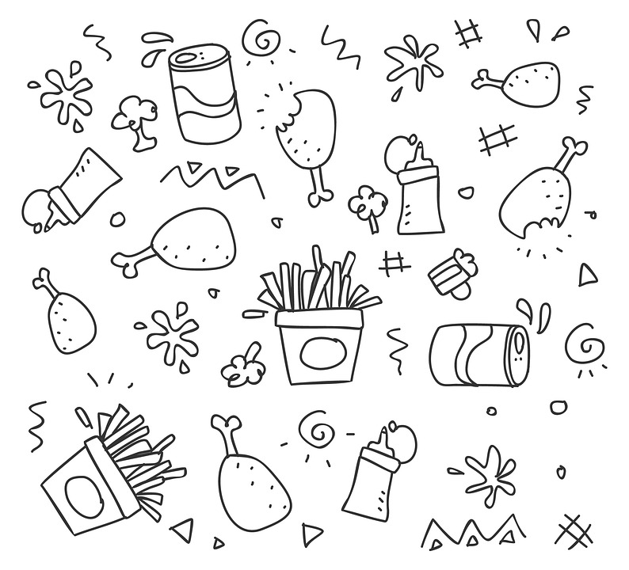


ice cream | pepper | chocolate | salad
potato | milk | meat | cheese
chicken | chips | cookies | jam
cola | fish | spaghetti | hamburger
tea | coffee | milkshake | juice
cucumber | tomato | avocado | water
bread | carrot | cake | onion
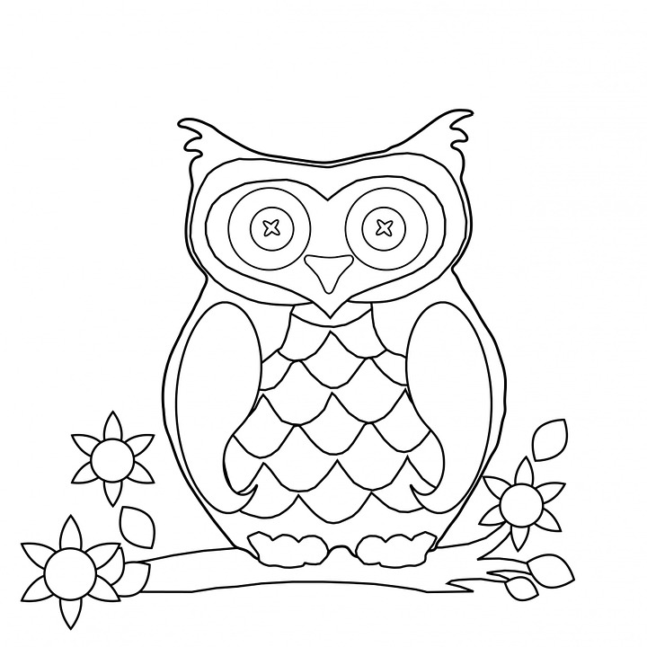
Digraph Coloring (CH, TH, SH)
Read the words written on the picture and color by code.
קראו את המילים שנכתבו על התמונה וצבעו לפי הקוד.
chip

wish
shop
chin
the

cheese
chocolate
thirsty
this
three
ship
chips
thin
Thelma
that
chicken
shell

Color Code:
Ch – brown
Th – yellow
Sh - green

During this unit, students:
- Became familiar with food words
- Practiced colors
- Learned the CH, TH, SH digraphs

Closing: After each session before you say goodbye, ask students to reflect on the lesson.
- Fellow asks: What is one thing you liked about the lesson?
- Ask each student to tell you 3 new English words they learned today.
- Repeat the new words after the student says them. Then, repeat the new words with the student again so he/she practices and learns the correct pronunciation.
- Ask: What is one question you still have about what you learned today?
- Say goodbye to the students. Tell them you are looking forward to seeing them next time… Fellow says: Have a good day/afternoon… See you next time…

Name:___________________
Unit 1 Quiz
Part A
Fill in the food words according to the correct starter.
השלם את המאכל המתאים למשפט (לא משנה הסדר).
I'm hungry. I want ____________ , ____________ and ____________ .
I'm thirsty. I want ____________ , ____________ and ____________ .
hamburger, chips, apple, ice cream, tomato, cucumber, fish, chicken, chocolate
water, cola, juice, coffee, tea, milkshake

Part B
Read the text and write the food orders of each student under the appropriate picture.
קראו את הטקסט וכתבו מתחת לכל מאכל את שם התלמיד/ה שרוצה אותו.
Ben: I'm hungry. I want chips and a hamburger.
Shira: I'm thirsty. I want a milkshake, please.
Alex: I'm thirsty. I want cola.

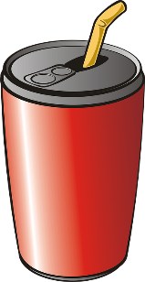
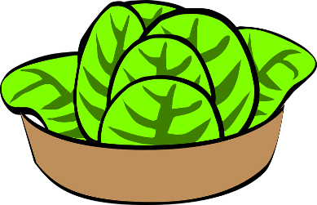
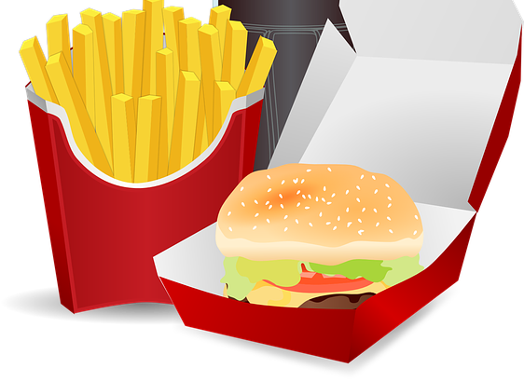
Tamar: I'm hungry. I want a salad and bread.
___________________
___________________
___________________
___________________


Part C
Listen and number the words according to their order spoken.
הקשיבו ומספרו את המילים בסדר הנכון.
salad ___
___ jam
___ bread
chip ___
chicken ___
chocolate ___
shop ___
ice cream ___
chat___
shell ___

Part D
Translate the words from English to Hebrew.
תרגמו את המילים לעברית.
 | fish |  | hamburger |  | shelf
 | To eat |  | thirsty |  | cake
 | To drink |  | hungry |  | meat

Unit 1 Quiz – ANSWERS
Part C
Read aloud to students in the order below:
salad _5_
_4_ jam
_10_ bread
chip _1_
chicken _6_
chocolate _7_
shop _2_
ice cream _3_
chat_8_
shell _9_

Part D
Translate the words from English to Hebrew.

דג | fish | המבורגר | hamburger | מַדָּף | shelf
לאכול | To eat | צָמֵא | thirsty | עוגה | cake
לשתות | To drink | רעב | hungry | בשר | meat

