Click 1 Unit 3 - Animals Activities
3rd Grade
Opening: Write the day and date on board. We suggest you start the session with a song or video. (see below) Fellows and students greet each other. Engage in a conversation with the students about some of these familiar topics.
· Fellow says: “Good morning/afternoon, students!”
o Students say: Good …!
· Fellow says: “It’s nice to see you again.”
o Students say: I'm glad to see you too. (Explain that glad means happy.)
· Fellow says: “Welcome to our lesson.”
· Fellow says: “My name is “…” “What’s your name?”
· Student says: “My name is “…” That student turns to next student and asks, “What’s your name?” The next student says… “My name is…” (Continue speaking and practicing names with each student in the group.)
· Fellow asks: “How are you? What’s new?”
  - Student says: I'm good/ I'm fine/ I'm all right
· Fellow asks: “How is your day?” Student says: It is good. / My day was great/fine.
· Fellow asks: What time is it?
  - Song for young kids with body movements:
  - Click here to access "What time is it?" song
· Fellow asks: “What day is today? What day was yesterday? What day will it be tomorrow?”
  - Click here to access "Days of the Week" song Early Elementary
· Fellow asks: “What season are we in now?”
o Click here to access "If you know all the seasons, clap your hands... Song Early Elementary
· Fellow asks: “What is the month?” Practice saying today is “…….” with students. Elementary and Young Juniors
· Fellow asks: “How’s the weather?” Early Elementary song:

  - Click here to access "How's the Weather?" video

o Students practice saying: It is cloudy/ it's rainy/ it's hot/ it’s nice/ sunny/ windy / cold / foggy…
· Fellow asks: “Are you ready to start our activities today?”
  - Students: “Yes!!”

Need help calming your students down? Try this: How to Calm Young Children Down in Minutes – Palming technique – Early Elementary (grades 1-4) Video:
o Click here to access: How to calm young children down in minutes

Objectives: In this unit, the students will practice:
- Vocabulary acquisition
- Individual letters
- Single letter sounds
- Capital & undercase letters

Animal Matching
Match pictures with words by writing the appropriate number by the animal picture.
כתבו את המספר של כל חיה בתמונה שלה למטה.

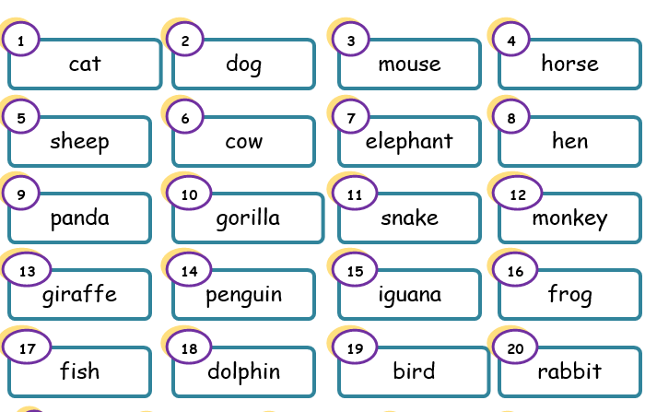

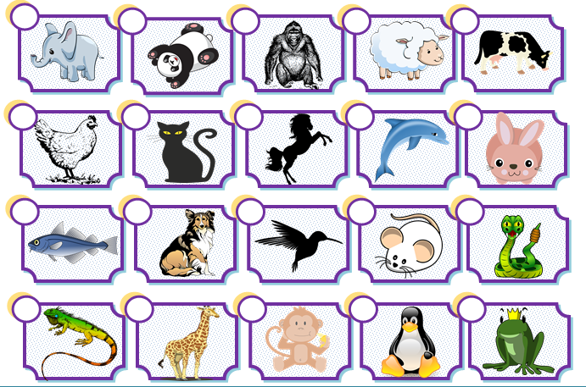
Let's Write Letters
Write the letter that each pair of pictures starts with.
כיתבו את האות הראשונה של כל זוג מילים.
e a g c m d t s

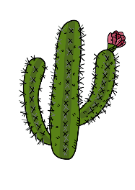 | 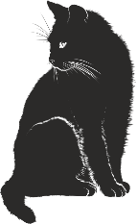
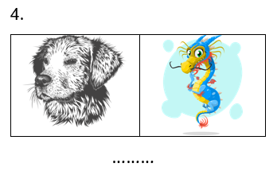
1.

………
c
………
 | 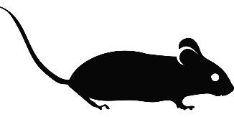
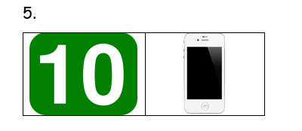
2.

………
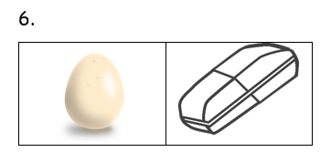
………
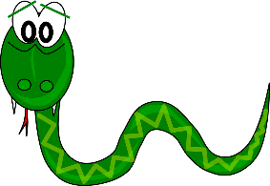 | 
3.

………
………

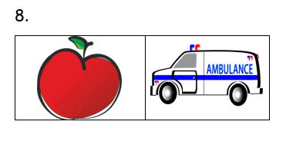
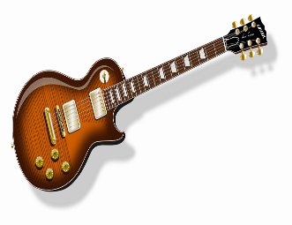 | 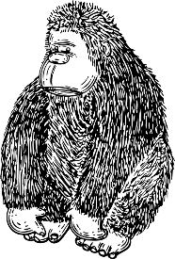
7.

………

………

Color the Octopus Treasure!
Color the big letters and small letters the same color.
ציבעו את האותיות הגדולות והקטנות המתאימות באותו הצבע.


T

C
I
H
E
W
i
G
g
h

e
a
C
w
t

Letter Sound Matching
For each word below, write its letter sound in the appropriate box.
כיתבו את המילים בקבוצות המתאימות.
pit map bed tan wet tip
can win tin hen sad step
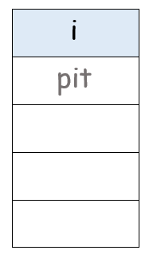
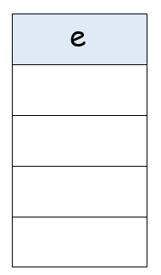
a

During this unit, students:
- Practiced correct uppercase/lowercase letters
- Started working with a, e, i sounds

Closing: After each session before you say goodbye, ask students to reflect on the lesson.
- Fellow asks: What is one thing you liked about the lesson?
- Ask each student to tell you 3 new English words they learned today.
- Repeat the new words after the student says them. Then, repeat the new words with the student again so he/she practices and learns the correct pronunciation.
- Ask: What is one question you still have about what you learned today?
- Say goodbye to the students. Tell them you are looking forward to seeing them next time… Fellow says: Have a good day/afternoon… See you next time…

Name: ________________
Unit 3 Quiz
Part A
Complete the following chart:
השלימו את הטבלה עם האותיות החסרות. הוסיפו צליל:
צליל - Sound | אות קטנה Small letter - | אות גדולה – Capital letter

Part B
Listen and circle the correct Hebrew word:
קראו את המילה באנגלית והקיפו את הפירוש המתאים:
ראש | אבא | ישראל | Israel
עט | דג | פיל | fish
כלב | חתול | ארוך | long
מים | בית ספר | קוף | water
מתחת | קצר | ארוך | short
כבשה | נחש | ג'ירפה | sheep
סוס | ציפור | רזה | thin

Part C
Fill in the missing letter for each picture:
כיתבו את האות החסרה של כל תמונה.
e____e | 
ar_____ | 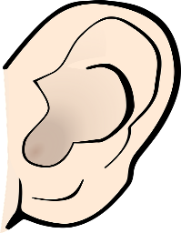
mou____h | 
n____se | 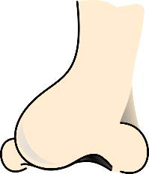
w____ng | 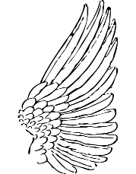
____eg | 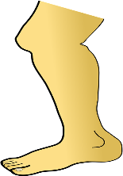
ta____l | 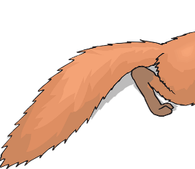

Part D
Translate into Hebrew:
תרגמו לעברית:
This is a cat. - _________________________________________________

I like this sandwich. - ____________________________________________

The giraffe is tall. - ____________________________________________

I can see two fish. - ____________________________________________

What is your name? - ____________________________________________

Unit 3 Quiz - ANSWERS
Part A
Complete the following chart:
For this chart, say each letter out loud and have them fill in the rest of the details.
צליל - Sound | אות קטנה Small letter - | אות גדולה – Capital letter
אֶן | n | N
טִי | t | T
אִי | e | E
דַאבְּלְיוּ | w | W
פִּי | p | P
סִי | c | C
אֵיְיץ' | h | H
אַי | i | I
בִּי | b | B
אֶס | s | S
דִי | d | D
אוֹ | o | O
גִ'י | g | G
אֵי | a | A

Part B
Listen and circle the correct Hebrew word:
קראו את המילה באנגלית והקיפו את הפירוש המתאים:
ראש | אבא | ישראל | Israel
עט | דג | פיל | fish
כלב | חתול | ארוך | long
מים | בית ספר | קוף | water
מתחת | קצר | ארוך | short
כבשה | נחש | ג'ירפה | sheep
סוס | ציפור | רזה | thin

