Click 1 Unit 1 – Meet the Characters Activities
3rd Grade

Opening: Write the day and date on the board. We suggest you start the session with a song or video (see below). Teacher and students greet each other. Engage in a conversation with the students about some of these familiar topics.

- Welcome to our lesson.
- Good afternoon, students!
Good afternoon, teacher!
- It’s nice to see you again.
I'm glad to see you too. (Explain that glad means happy.)
- How are you? What’s new?
I'm good/ I'm fine/ I'm all right
- How was your day?
It was good/ It was great/fine
- What time is it now?
- What day is today? What day was yesterday? What day will it be tomorrow? https://www.youtube.com/watch?v=h84PF1zocdQ https://www.youtube.com/watch?v=7AvNq2CQnOI
or
- What season are we in now? https://www.youtube.com/watch?v=rZ6NJWNzBqE
- What is the month? Month video: https://www.youtube.com/watch?v=rZ6NJWNzBqE
- What’s the weather like today? https://www.youtube.com/watch?v=rD6FRDd9Hew or https://www.youtube.com/watch?v=CXKj7bm4Ops
It is cloudy/ it's rainy/ it's hot/ it’s nice/ sunny/ windy
- Are you ready to start our activities today?
Yes!!

Objectives: In this unit, the students will practice:
- Absolute beginner vocabulary acquisition
- Word/letter sounds
- Numbers

Bingo
Instructions:
Play bingo using the cards below. You will need "placeholders" for each student so they can mark which words have been called out. There are 8 different bingo boards to print out, preferably in color. Each student should receive one bingo card OR you can pair two students up and they will play as a team.
Aim of the game:
To be the first one to fill in four squares horizontally, vertically, or diagonally.
כללי המשחק:
- שחקנים מוצאים את המילה על הלוחות שלהם, לכסות אותו עם שעועית או כפתור.
- השחקן הראשון שיש "בינגו" (ארבעה ברציפות בכל כיוון - אנכי, אופקי, אלכסוני)
מנצח
- יש אפשרות לשחק כצוות בזוגיות.

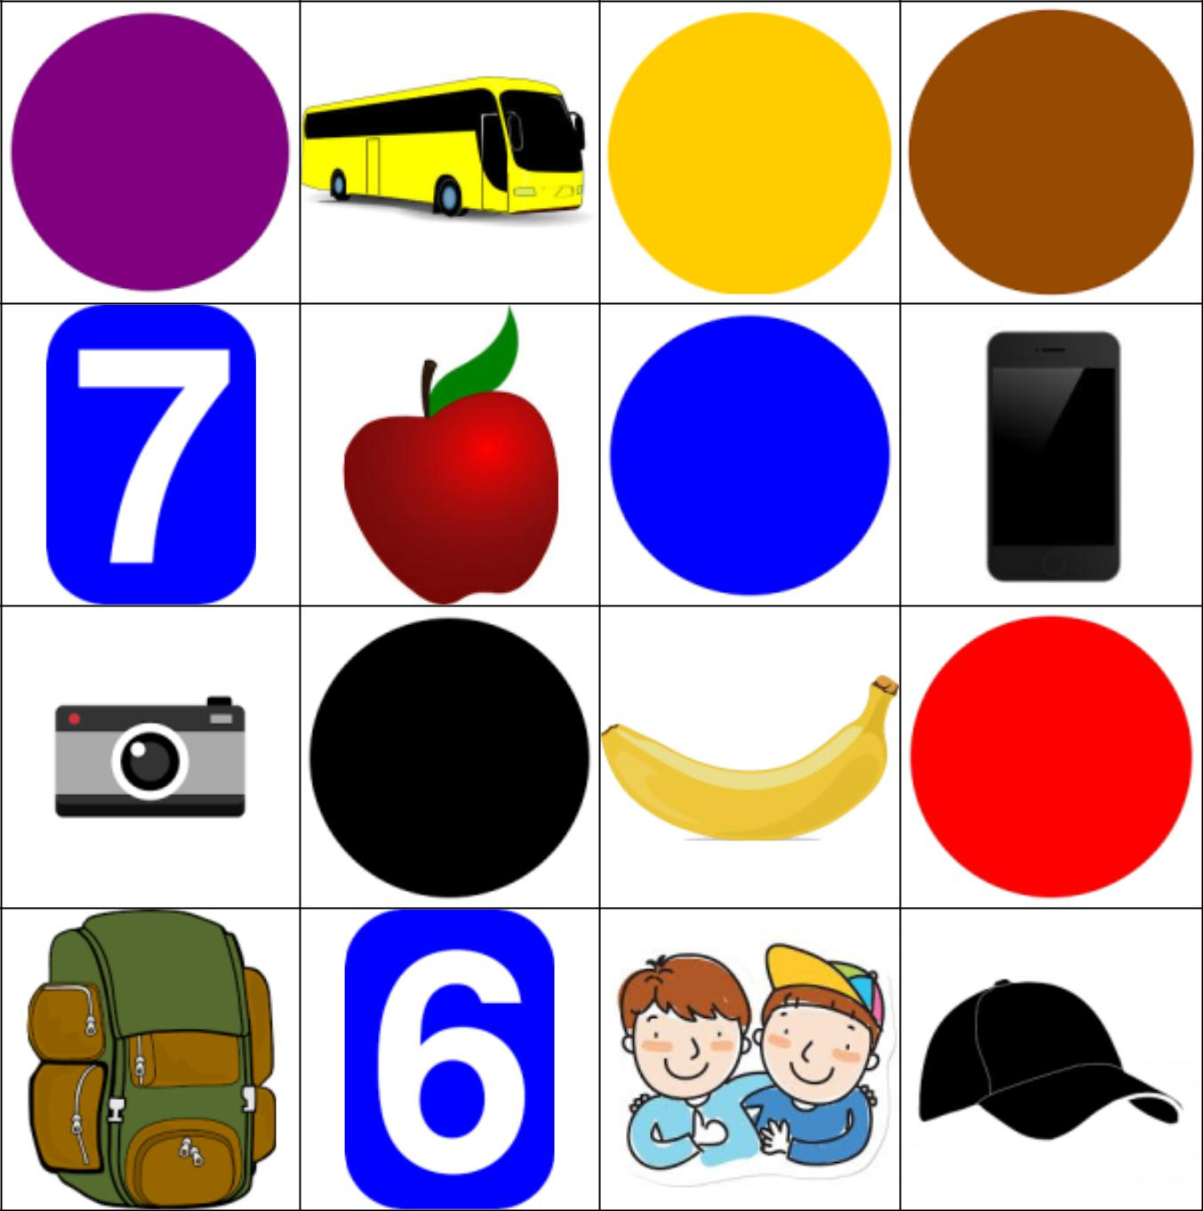

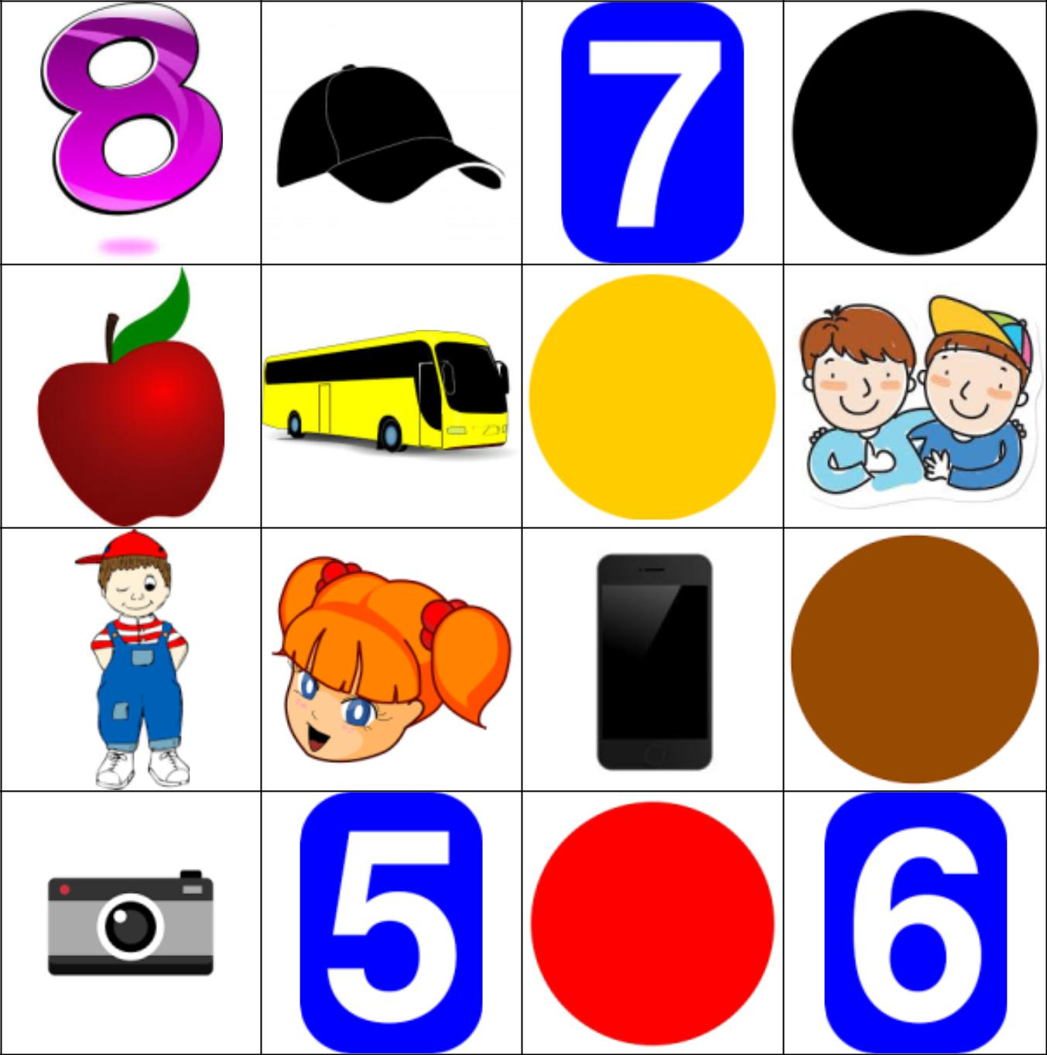

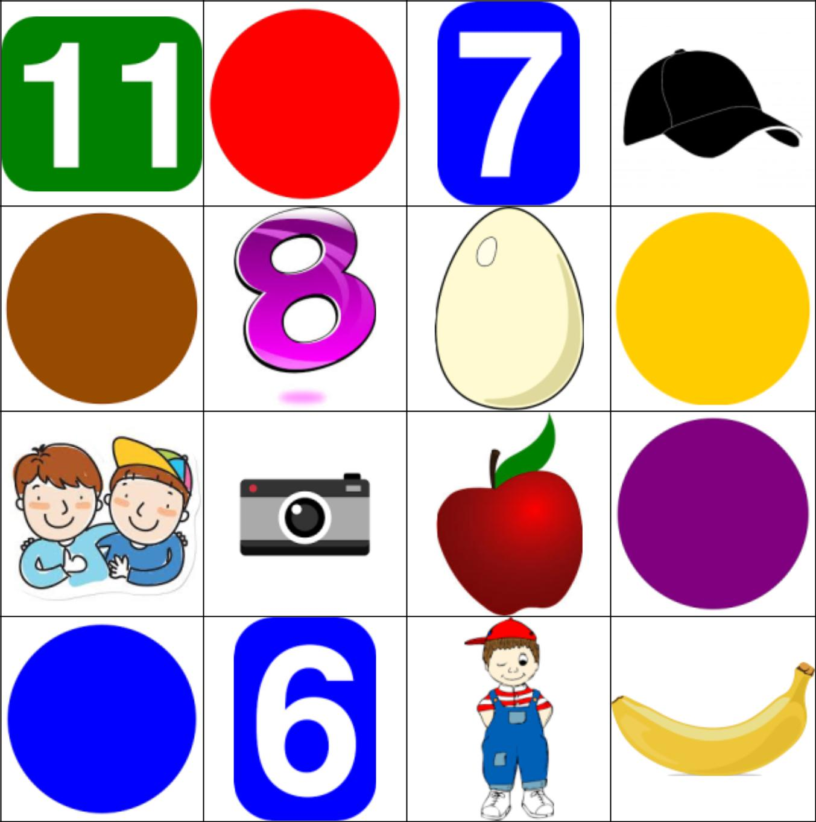

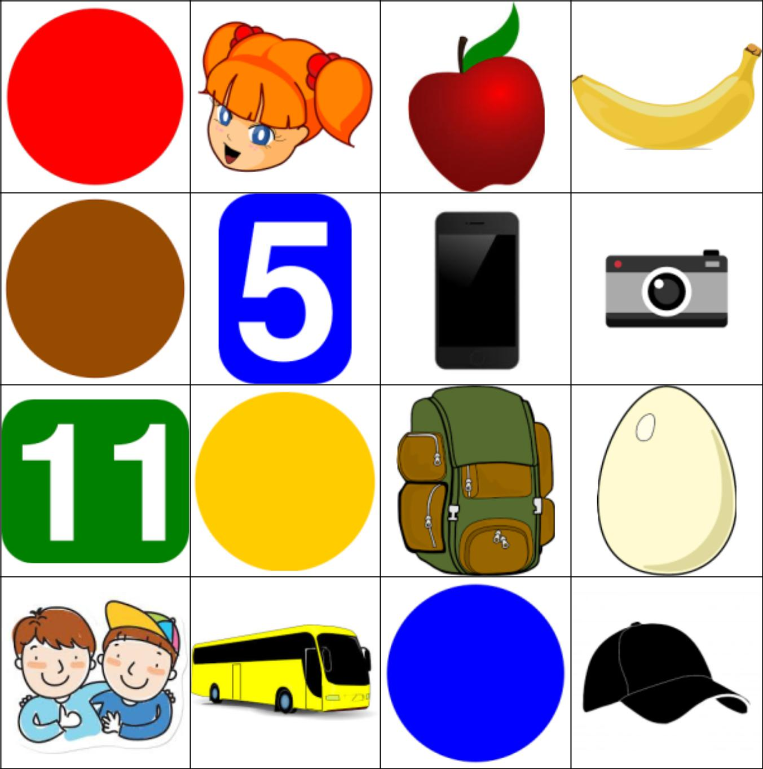

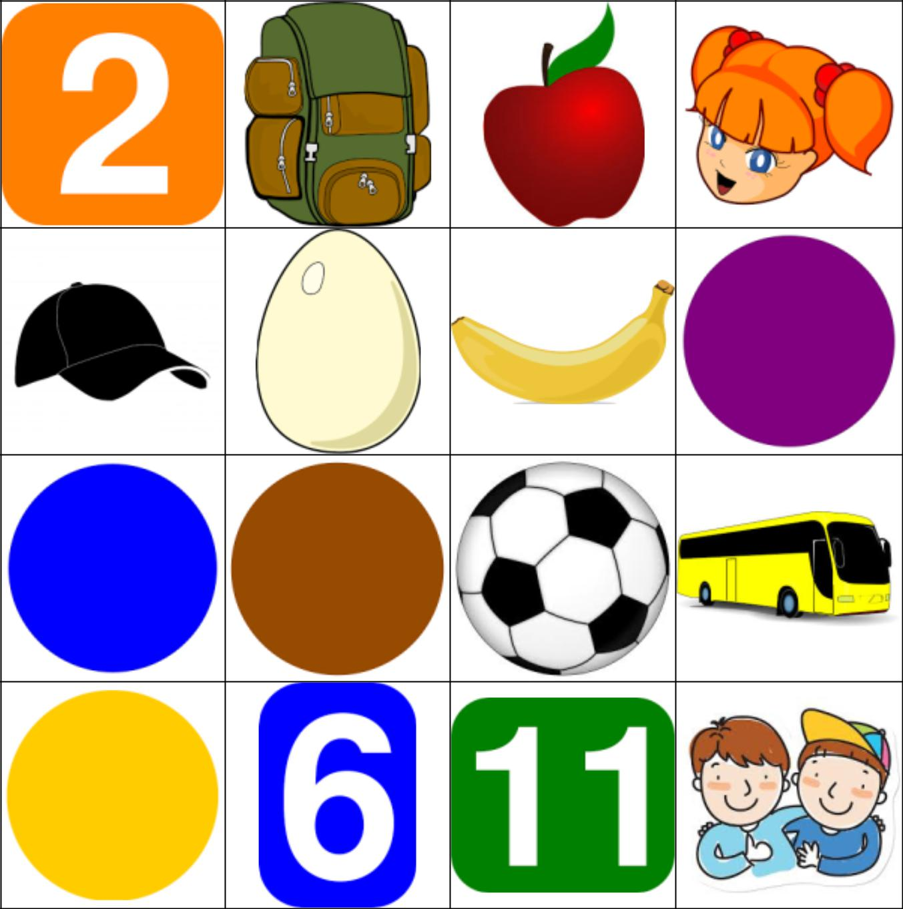

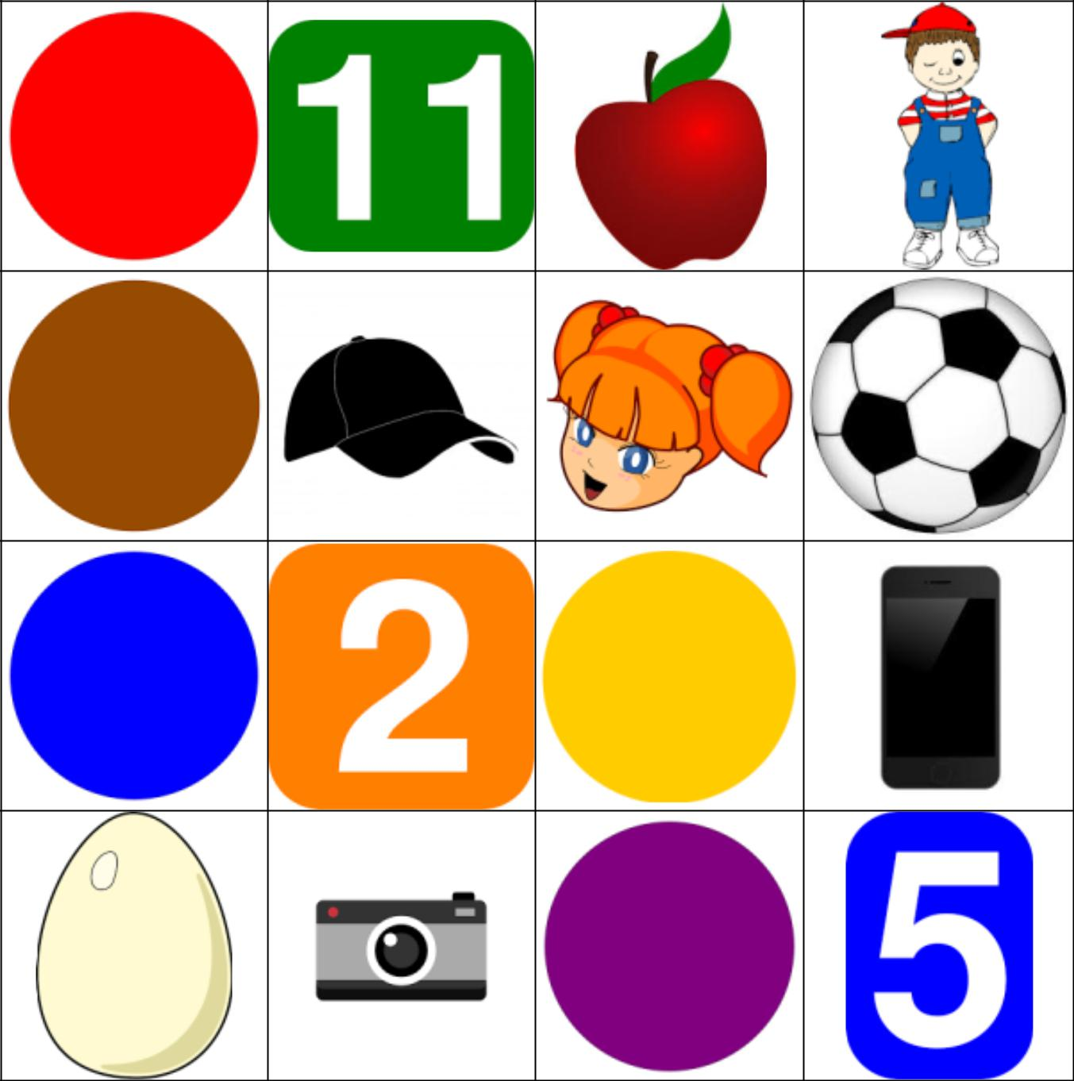

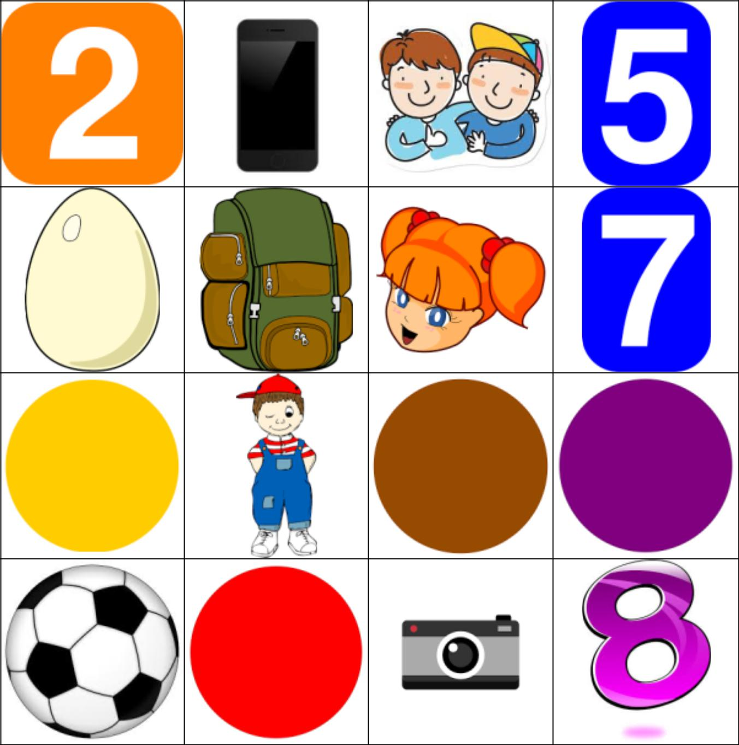

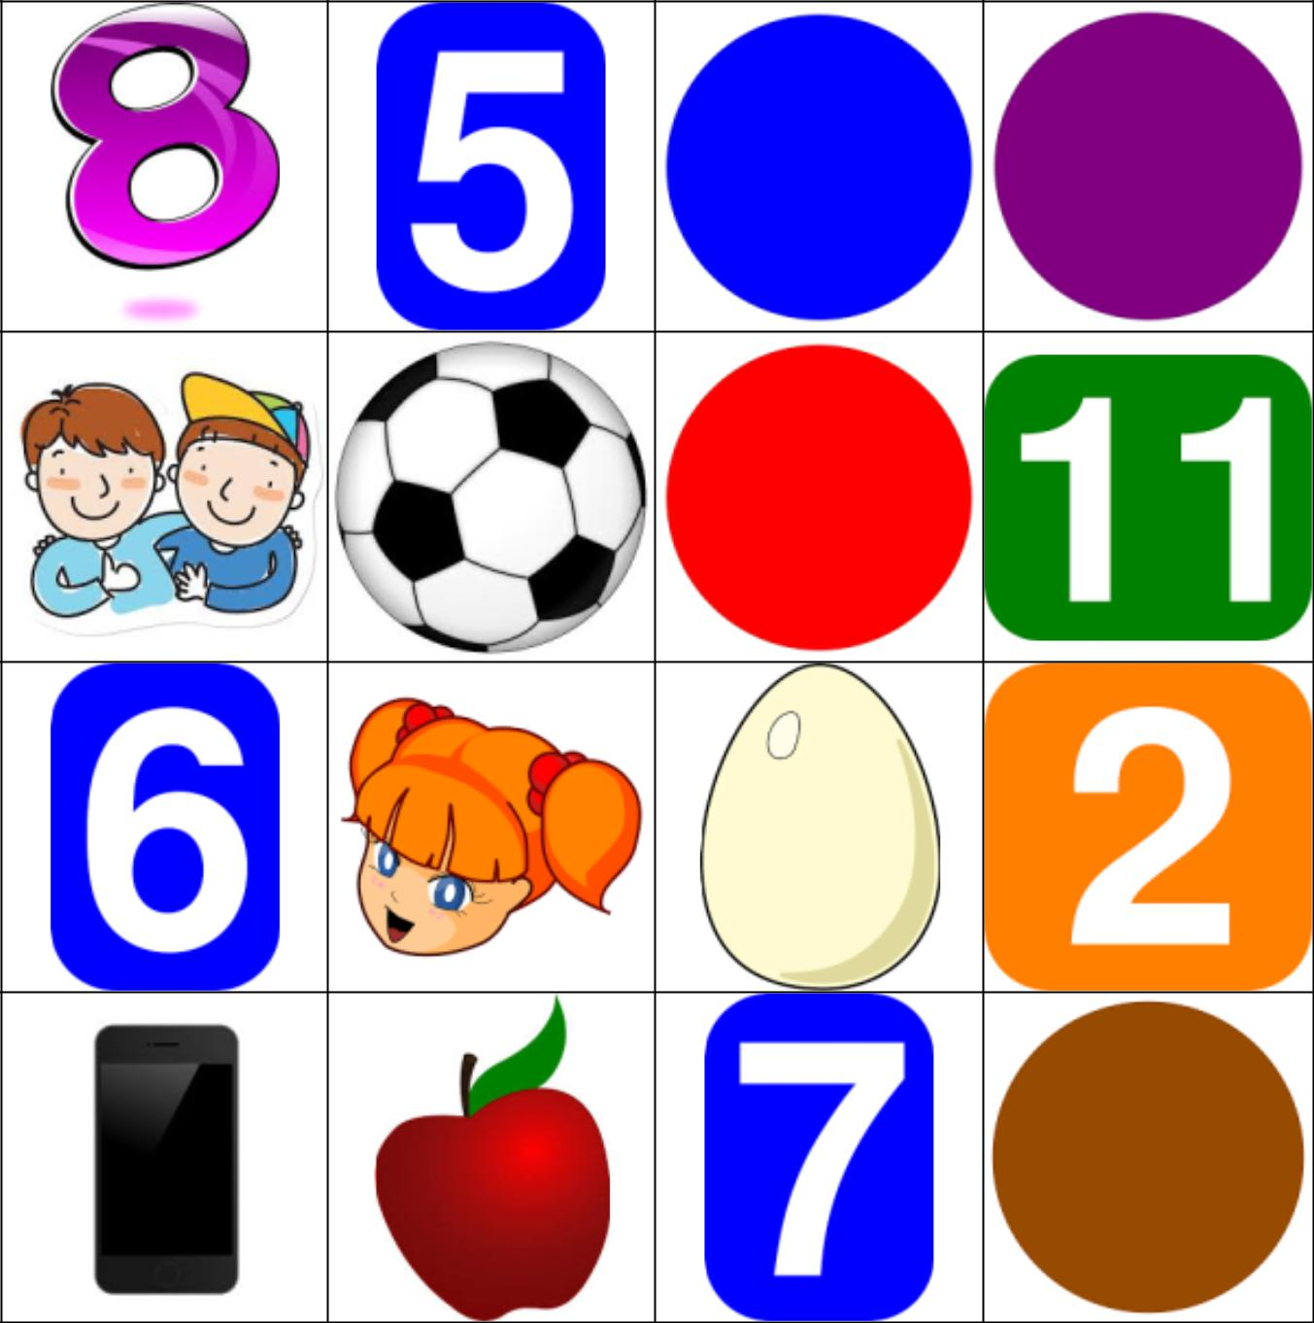

Use this randomly generated list as your call list when playing the game. Cross out each word as you announce it, to keep track. You can also cut out each item, place them in a bag and pull words from the bag.

1. 2. 3.





4. 5. 6.





7. 8. 9.

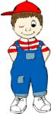
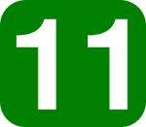


10. 11. 12.





13. 14. 15.

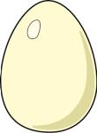


16. 17. 18.

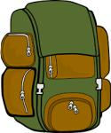


19. 20. 21.





22. 23. 24.





Snakes & Ladders

Preparation: Glue board on stiff back and cut out (lamination optional).
Play: Play in small groups of 2-4. Roll one or two dice and move your “soldier” forward. When you land on a square, you read the word aloud. If you land on a ladder you climb up. If you land on a snake you slide down. If you know the definition of the word, you can choose to have another turn (or if you landed on a snake you can choose not to slide down.) The first person to reach FINISH wins. (Or make up your own rules.)

כללי המשחק:
לגלגל קוביה אחת או שתיים ולהזיז את החייל שלך קדימה. קרא בקול את המילה בריבוע עליו נעצרת. אם אתה נוחת על סולם, אתה מטפס. אם אתה נוחת על נחש, אתה חייב להחליק למטה. אם אתה יודע את התרגום של המילה, אתה יכול לבחור אם יש לך עוד תור (או אם נחתת על נחש אתה יכול לבחור לא להחליק למטה.) האדם הראשון להגיע ל-סיום מנצח.

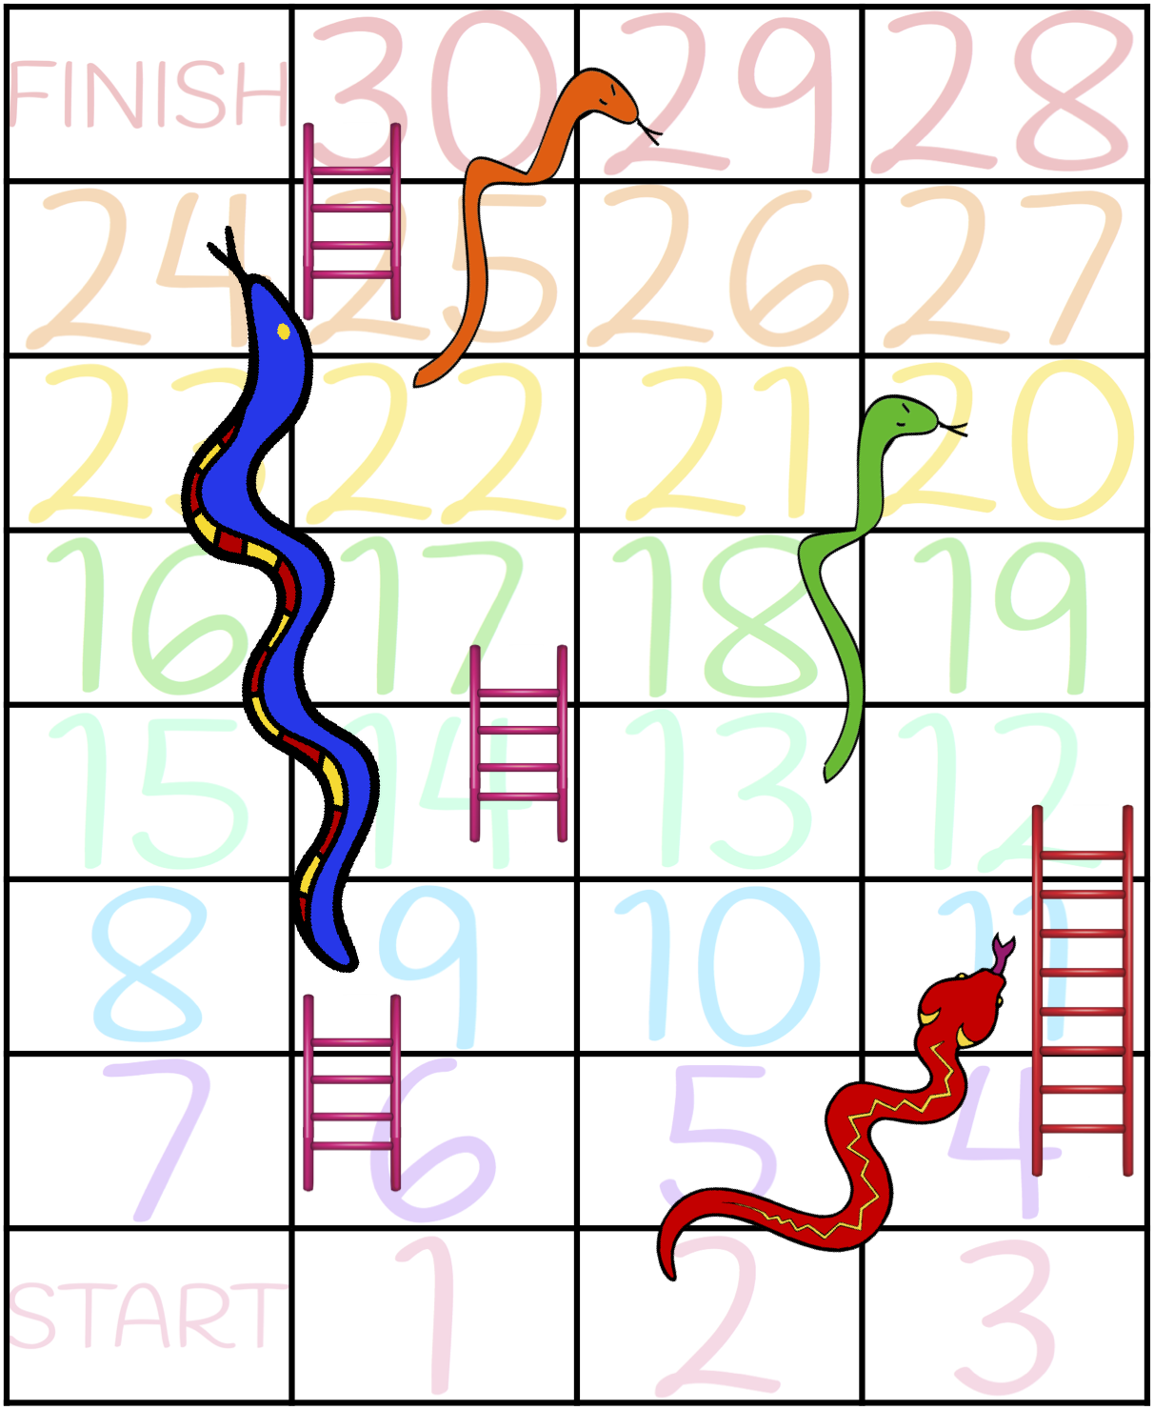
9
banana
11
Anna

sad |  | Ben  men | bad
cap | 5 | Anna | man
door | ant | 7pen | pen
net
3
10
madddddd

6
bed
8
name

on
4
I have
book

cat
1
pan
bag
During this unit, students:
- Started learning ABC letters
- Associated colors from written language to their appearance
- Began simple word sounds
Closing: Reflect on the lesson.
- For younger students, ask one thing they liked about the lesson.
- What new thing did they learn?
- For older students, ask what was special about the lesson.
- What is one question they still have?
- What would they like to learn more about?

Say goodbye to students. Tell them you are looking forward to seeing them next time… Have a good afternoon…

Name: _________________
Unit 1 Quiz
Part A
Color the flowers according to the teacher's instructions:
צבעו את הפרחים לפי הוראות המורה:
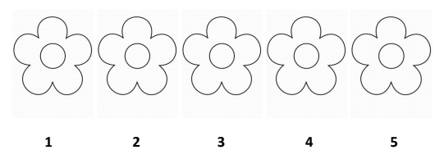

Part B
Complete the small letter:
השלימו את האות הקטנה:
A ___________

B ___________

G ___________

P ___________

E ___________

Part C
Write the name of the word under its picture. Use the word box:
כתבו את שם המילה מתחת לתמונה המתאימה. השתמשו במחסן המילים:





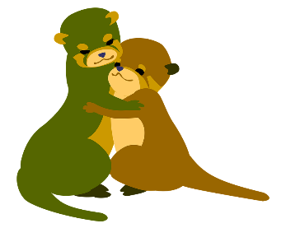

מחסן המילים
phone, friend bus, camera, egg,

Part D
Match the letters:
התאימו אות קטנה לאות גדולה:
G a

E p

P e

A b

B g

Part E
Circle the number the teacher says:
הקיפו את המספר שהמורה מקריאה:
11 | 8 | 0 | 6
4 | 2 | 11 | 2
5 | 9 | 9 | 10
3 | 0 | 7 | 7
12 | 1 | 2 | 6

Quiz for Unit 1 – ANSWERS
Part A
YELLOW GREEN PINK PURPLE BROWN

Part B
Complete the small letter:
A _____a______

B _____b______

G ______g_____

P ______p_____

E _____e______

Part C
Write the name of the word under its picture. Use the word box:


camera
bus

phone
friend
egg

מחסן המילים
phone, friend bus, camera, egg,

Part D
Match the large letters to its undercase:
G a

E p

P e

A b

B g

Part E
Circle the number the teacher says:
11 | 8 | 0 | 6
4 | 2 | 11 | 2
5 | 9 | 9 | 10
3 | 0 | 7 | 7
12 | 1 | 2 | 6
Zero, eleven, five, six, ten

